Changes to reflect requirements under the Major Criminal Cases Framework

This ATLAS user guide provides information about completing the amended ‘Simplified Process – Committal Mention and/or Plea in the County Court’, ‘Simplified Process – Committal Mention and/or Plea in the Supreme Court, ‘Simplified Process – Indictable Crime – Trial’ application form, ‘Submit Correspondence’ and ‘File Outcome’ menu items.

Glossary
‘Major Criminal Case’ includes committals exceeding four days and criminal trials likely to last more than 15 days in duration (including severed trials less than 15 days that collectively equate to more than 15 days).

New features in the Simplified Process – Committal Mention and/or Plea in the County Court and Simplified Process – Committal Mention and/or Plea in the Supreme Court application forms
There are three new menu items:
- CO-ACCUSED
- CO-ACCUSED DETAILS
- DOCUMENT REMINDER / DOCUMENTS

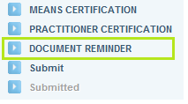
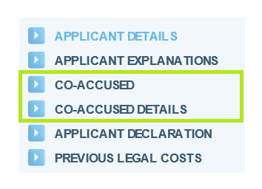
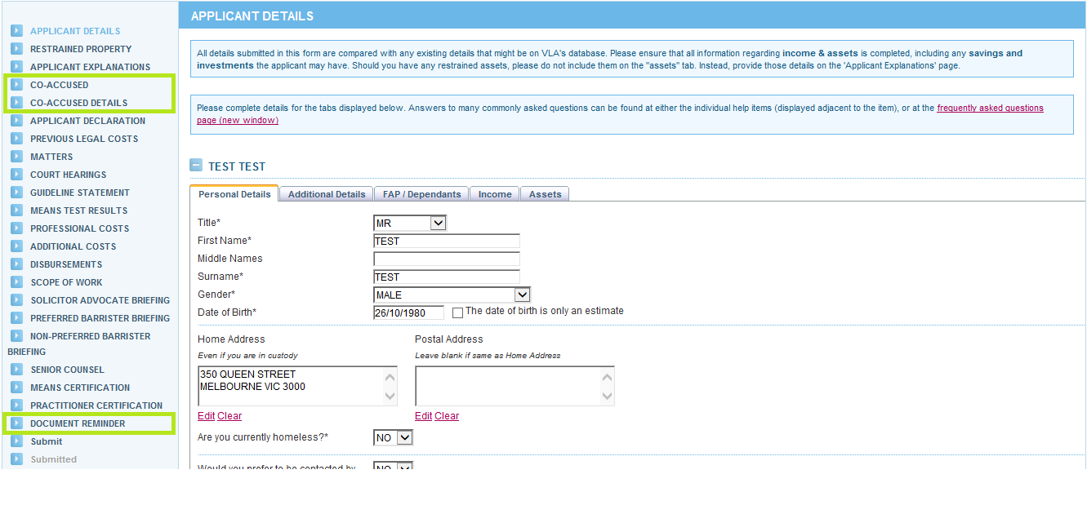

Co-accused
From 1 February 2016, practitioners seeking a grant of legal assistance or an extension of legal assistance for a major criminal case must provide details of all co-accused.
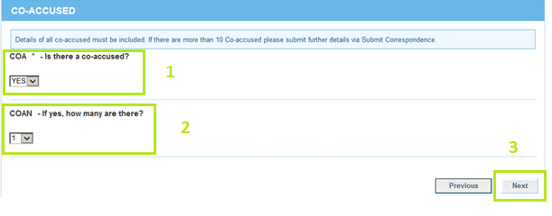
- Select ‘Yes’ or ‘No’ depending on whether there are any co-accused.
- If you select ‘Yes’ you must select the number of co-accused at field COAN, even if it is more than 10 co-accused.
- If you select ‘Yes’, complete field COAN and click ‘Next’ you will proceed to the CO-ACCUSED DETAILS screen. If you select ‘No’ and click ‘Next’ you will skip the CO-ACCUSED DETAILS screen and move to the APPLICANT DECLARATION screen.
NOTE In applications seeking extensions of legal assistance, you only need to enter co-accused details for those you have not already provided to Victoria Legal Aid. When in doubt, you should provide the details of all co-accused.

Co-accused details
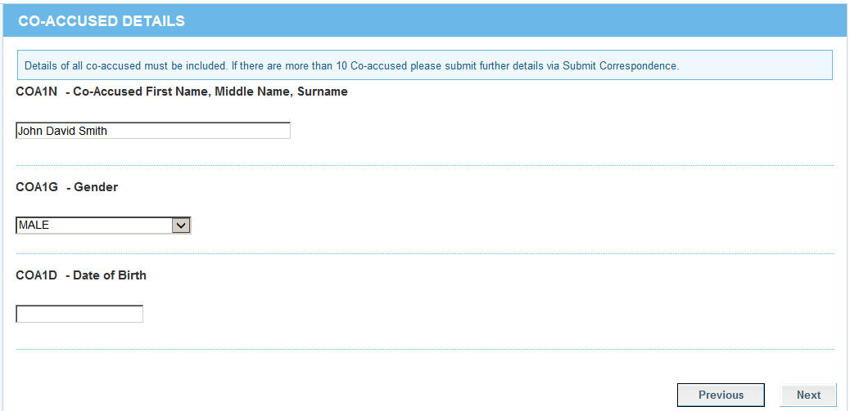
- You can only enter details for a maximum of 10 co-accused, even where you select a number more than 10 at field COAN on the CO-ACCUSED screen. If there are more than 10 co-accused, you must provide details of the remaining co-accused (full name, gender and date of birth) via Submit correspondence – Co-accused.
- You may submit the application without having to complete every field on the CO-ACCUSED DETAILS screen. However, under the Major Criminal Cases Framework, you must provide co-accused details for all major criminal cases. If you do not have all of the co-accused details when you submit the application, for example the date of birth, you must provide this to Victoria Legal Aid at a later date via Submit Correspondence – Co-accused.

Documents
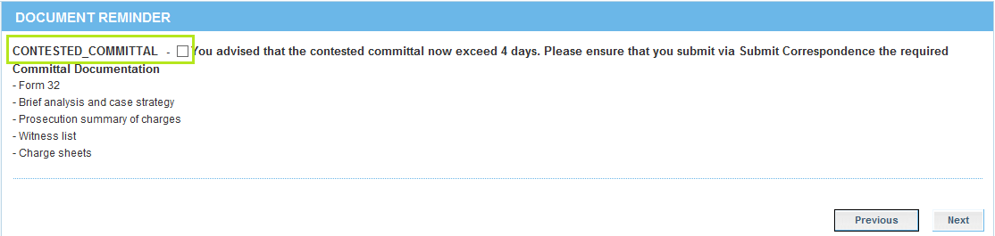
The DOCUMENT REMINDER screen will appear after you have completed the PRACTITIONER CERTIFICATION screen and when you have requested contested committal days exceeding four days. You may tick the field at ‘Contested Committal’ to acknowledge that you have read the information but it is not necessary to do so.
The following screens have been updated:
- PROFESSIONAL COSTS
- ADDITIONAL COSTS

Professional costs
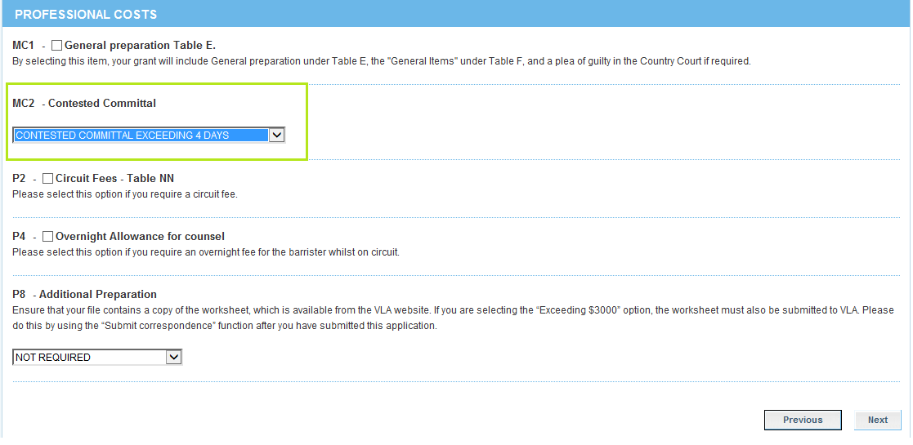
From 1 February 2016, practitioners may recommend up to and including 4 contested committal days.
Field ‘MC2’ has been amended and now includes the following drop down menu items:
- Contested committal exceeding 4 days
- Contested committal up to & including 4 days
- Limited committal – sexual offences cases
- No professional costs required
When you have a current grant of legal assistance for a contested committal and are seeking an extension of assistance for additional contested committal days, you will see the following PROFESSIONAL COSTS screen.
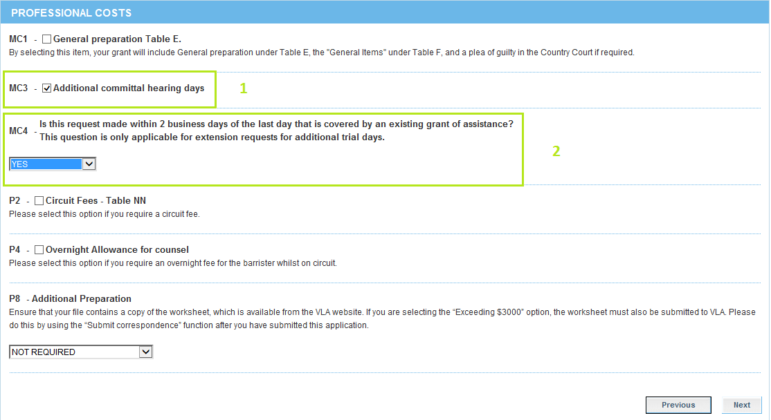
- If you are seeking assistance for additional contested committal days, you must complete fields ‘MC3’ and ‘MC4’.
- Field MC4 has three drop down menu items:
- Yes
- No
- Not applicable – select when you are seeking additional contested committal days prior to the commencement of the contested committal.
If you select ‘Yes’ or ‘Not applicable’ you will skip the ADDITIONAL COSTS screen and proceed to the DISBURSEMENTS screen.
If you select ‘No’, you will proceed to the ADDITIONAL COSTS screen.

Additional costs
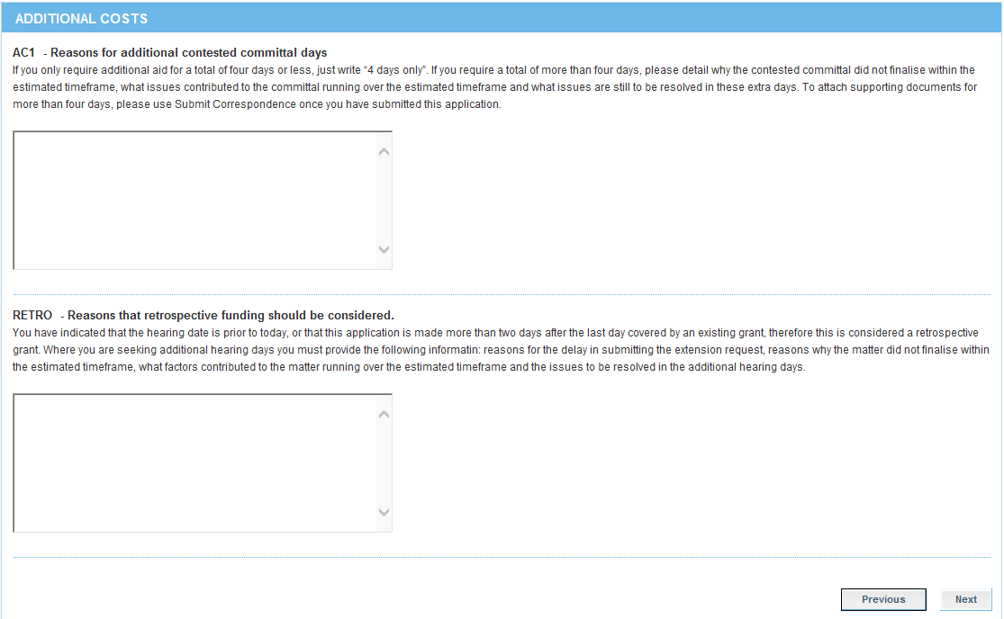

From 1 February 2016, practitioners must provide further information when requesting additional committal days that brings the total number of contested committals days to over four days. Practitioners are not required to provide further information when you are requesting up to and including four contested committal days (this is inclusive of any additional contested committal days).
- Field ‘AC1’ will appear if you tick the ‘MC3’ field on the PROFESSIONAL COSTS screen. This field must be completed for all requests for additional contested committal days.
From 1 February 2016, practitioners may request additional contested committal days within two business days of the last day that is covered under the contested committal grant of legal assistance (2 business day grace period). These requests will not be considered retrospective in nature. However, outside of this grace period, all requests will be considered retrospective.
- Field ‘RETRO’ will appear if you select ‘No’ at field ‘MC4’ on the PROFESSIONAL COSTS screen and must be completed.

New features in the Simplified Process – Indictable Crime - Trial application form
There are three new menu items:
- CO-ACCUSED
- CO-ACCUSED DETAILS
- DOCUMENTS / DOCUMENT REMINDER

Co-accused
The CO-ACCUSED screen is the same as the CO-ACCUSED screen on the ‘Simplified Process – Committal Mention and/or Plea in the County Court’ and ‘Simplified Process – Committal Mention and/or Plea in the Supreme Court application form’.
See page 2 for further information.

Co-accused details
The CO-ACCUSED DETAILS screen is the same as the CO-ACCUSED DETAILS screen on the ‘Simplified Process – Committal Mention and/or Plea in the County Court’ and ‘Simplified Process – Committal Mention and/or Plea in the Supreme Court’ application form.
See page 3 for further information.

Documents
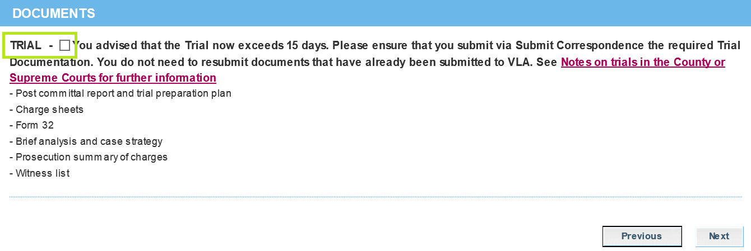
The DOCUMENTS screen will appear after you have completed the PRACTITIONER CERTIFICATION screen and when you have requested trial days exceeding 15 days. You may tick the field at ‘Trial’ to acknowledge that you have read the information but it is not necessary to do so.

The following screens have been updated:
- PROFESSIONAL COSTS
- ADDITIONAL COSTS

Professional costs
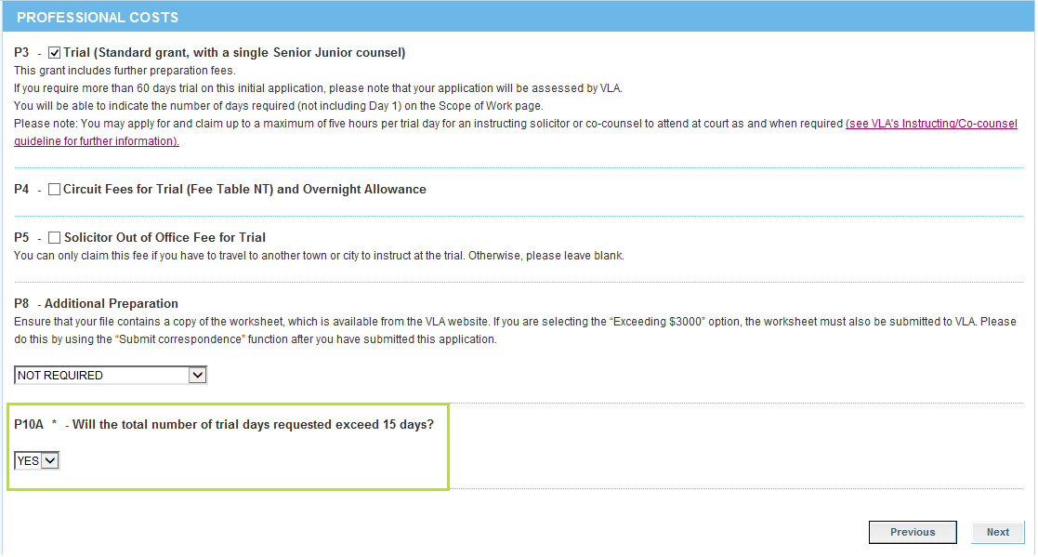
- ‘P10A’ is a mandatory field. Select ‘Yes’ or ‘No’ depending on how many initial trial days you are seeking.

When you have a current grant of legal assistance for a trial and are seeking an extension of assistance for additional trial days, you will see the following PROFESSIONAL COSTS screen.
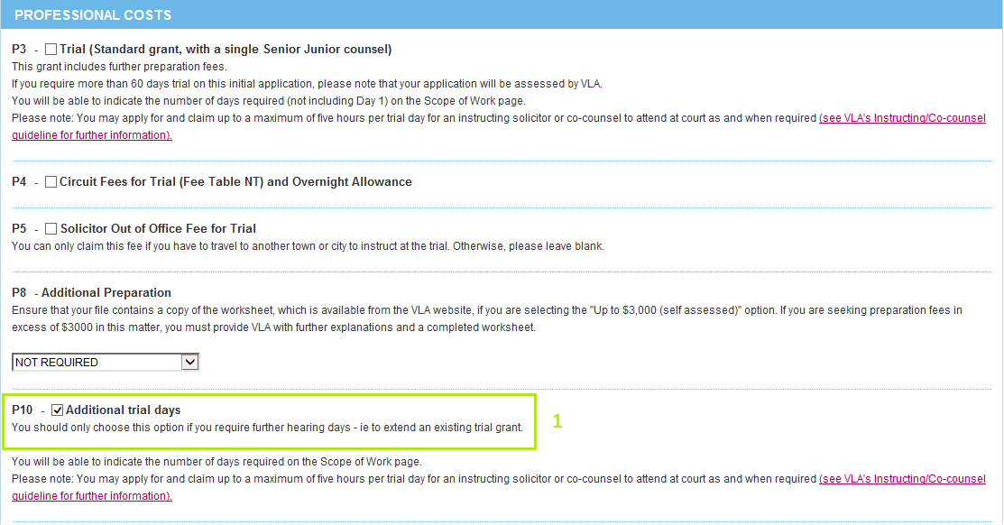
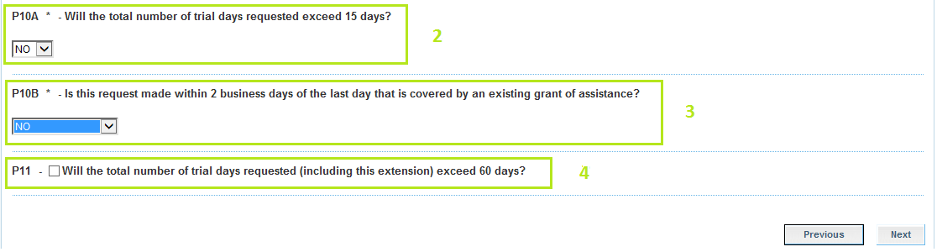

- You must complete field ‘P10’ if you are seeking additional trial days
- At field ‘P10A‘ select ‘Yes’ or ‘No’ depending on the total number of trial days you are seeking assistance for (this includes the additional trial days)
- Field ‘P10B’ has three drop down menu items:
- Yes
- No
- Not applicable – select when you are seeking additional contested committal days prior to the commencement of the contested committal.
If you select ‘Yes’ or ‘Not applicable’ you will skip the ADDITIONAL COSTS screen and proceed to the DISBURSEMENTS screen.
If you select ‘No’ you will proceed to the ADDITIONAL COSTS screen.
- Complete and check field ‘P11’ if you are seeking trial days over 60 days. If you check this field, you will proceed to the ADDITIONAL COSTS screen.

Additional costs
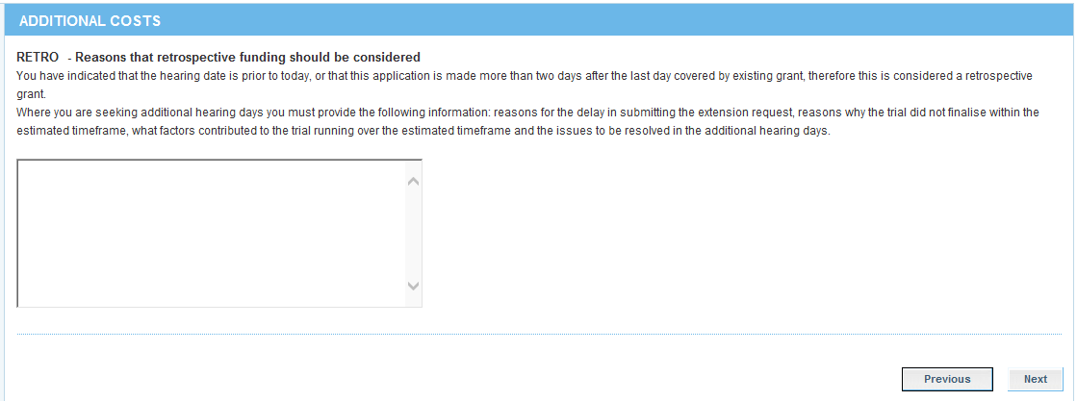

From 1 February 2016, practitioners may request additional trial days within two business days of the last day that is covered under the trial grant of legal assistance (2 business day grace period). These requests will not be considered retrospective in nature. However, outside of this grace period, all requests will be considered retrospective.
- Field ‘RETRO’ will appear if you select ‘No’ at field ‘P10B’ on the PROFESSIONAL COSTS screen. This must be completed.

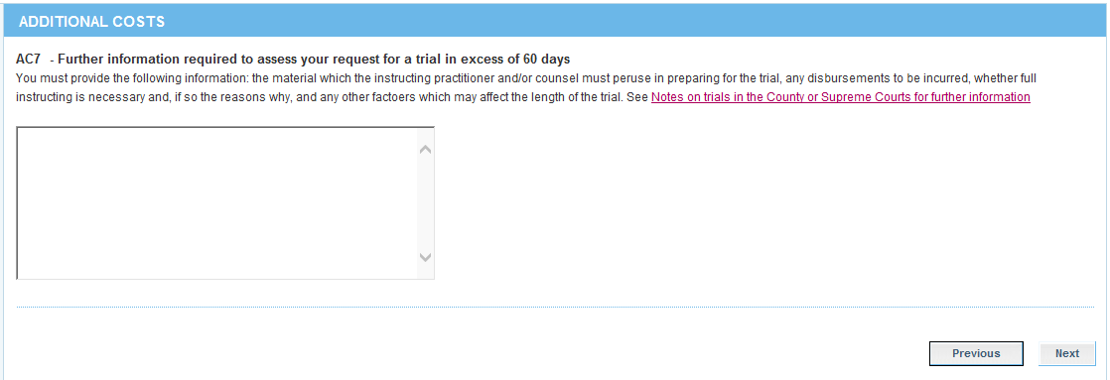

Practitioners can recommend a grant of legal assistance for up to 60 trial days. Practitioners must provide further information if seeking trial days in excess of 60 days (this is inclusive of additional trial days).

New features in the Submit Correspondence menu item

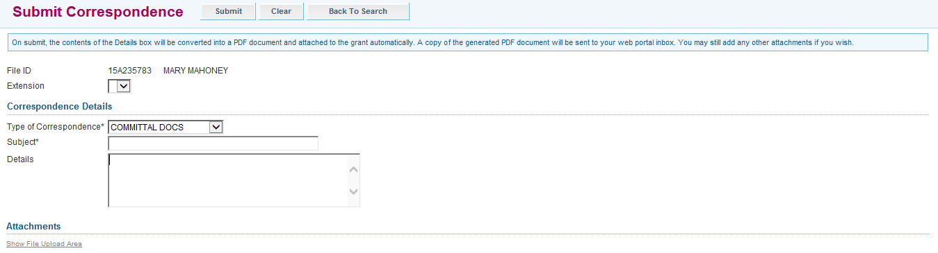

When you select ‘Indictable crime file outcome’, you will proceed to the above page. This has not changed. When you select ‘Next’ you will proceed to the DETAILS screen.
‘Type of Correspondence’ now includes the following menu items:
- Co-accused
- Committal docs
- General enquiry
- Police brief
- Proof of means
- Seeking exception
- Trial documentation
See Major Criminal Cases Framework for further information as to when and what documents you should submit.

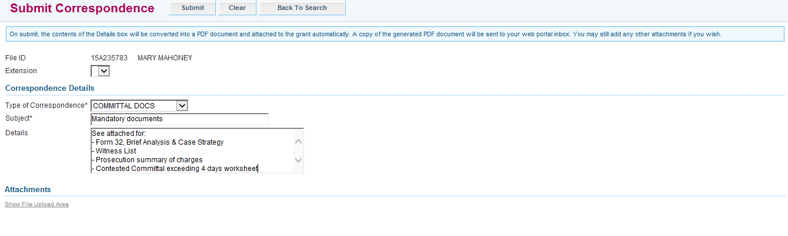

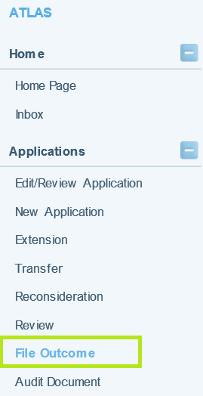
New features in the File Outcome menu item

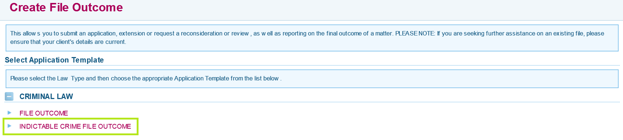
Complete the ‘Indictable crime file outcome’ for all indictable matters.

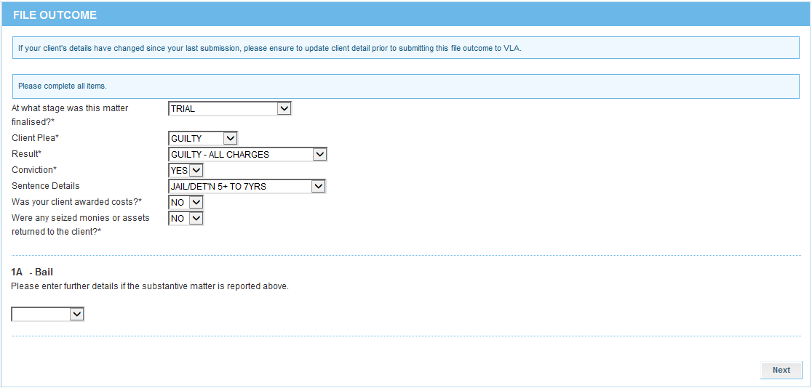

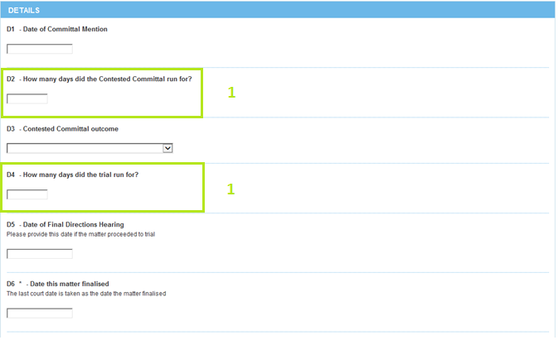
- Fields ‘D2’ and ‘D4‘ must be completed accurately. Victoria Legal Aid uses the information provided for reporting purposes.
- All other fields must be completed.

