An application or extension can be partially completed and saved. The draft can be retrieved at any time.
Note:
- Victoria Legal Aid can only process an application or extension that is submitted
- a draft or saved application or extension cannot be processed
- drafts are deleted from ATLAS after 90 days
Practitioners are reminded that signed application forms are declarations and therefore applicants must only sign the form once it is complete.
The completed application signed by the client must be retained on the file. Note that the applicant declaration page alone is not sufficient.

Retrieve a saved application or extension

- Select Edit/Review Application from the left hand menu under Applications.

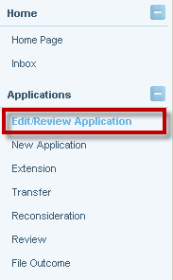

- The Search for Application screen displays. Enter the File ID and Select Search

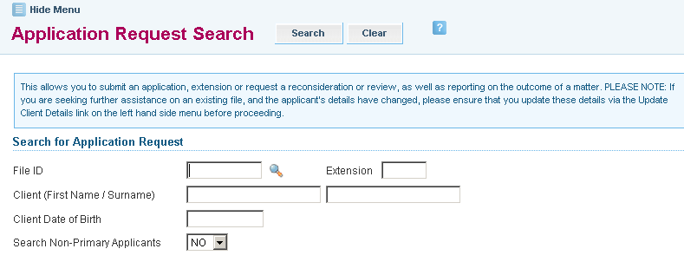

- To use the Advanced Criteria, click on the to expand the window

Additional search fields are as follows:
- Application Status
- Client ID
- Application Type
- Law Type
- Submitted date range
- Submitted By
- Office

Select Search

The following screen will display:
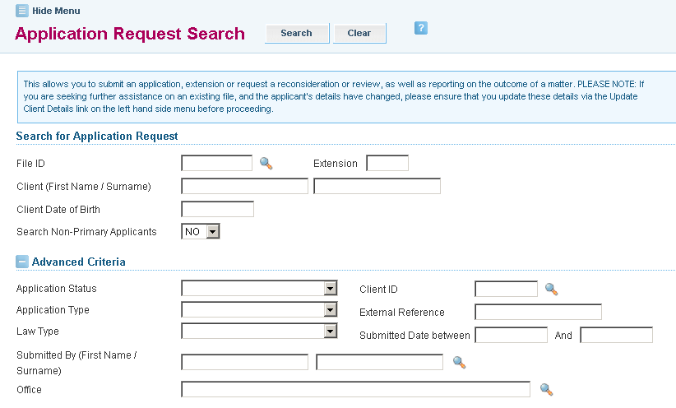

- Search Results will display. Click on the File ID link to retrieve the draft application.

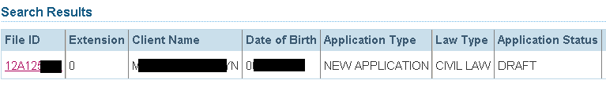

- The draft application will display. Complete all required sections. If mandatory information is omitted or has been entered incorrectly, the error(s) will be identified at the top of the page and an error message will display.

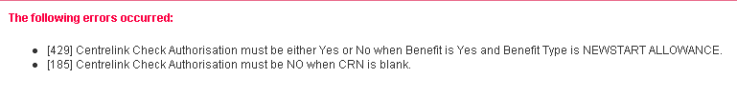

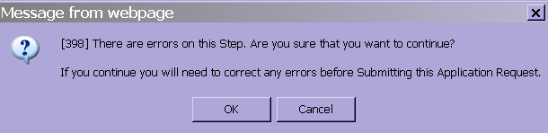

If you click you are moved to the next section. The error(s) accumulate and you must return to correct them before you are able to submit the application.

If you click you remain in the section where the error(s) occurred. Correct the error, click Next to validate the correction and you will be moved to the next section.

- The Practitioner Certification screen will display. The practitioner certifies that the application satisfies the applicable guidelines and merits tests. Complete the following fields and then select Next to proceed:
- Practitioner’s name (if not pre-populated)
Do not use symbols in any Reference field to avoid a systems error. Symbols are not compatible in ATLAS, for example:

. , / - + ( * ) ! @ # $ % ^ & _ *

- Date
- Practitioner’s Reference

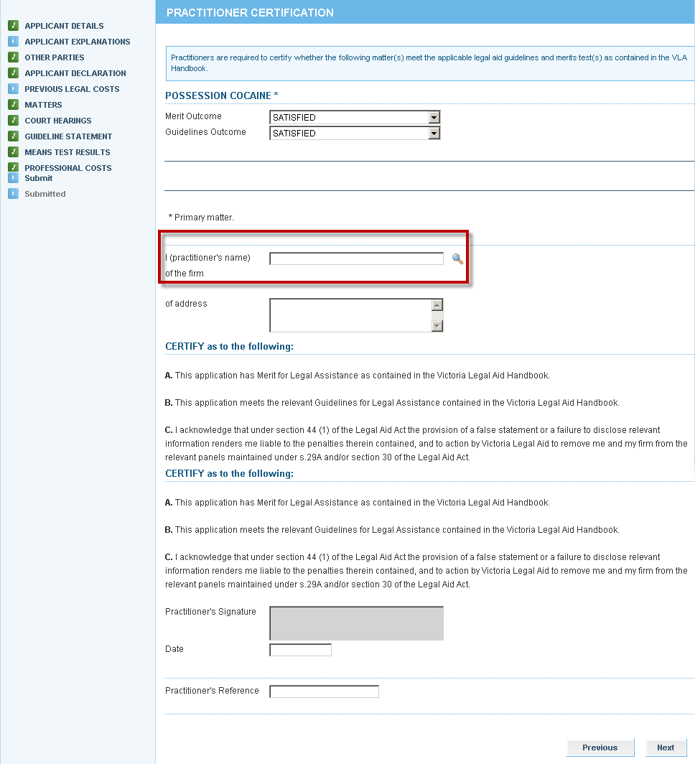

- The Submit screen will display. If required, Print a copy of the application to be signed by the client.
Select Submit to send it to Victoria Legal Aid for processing.
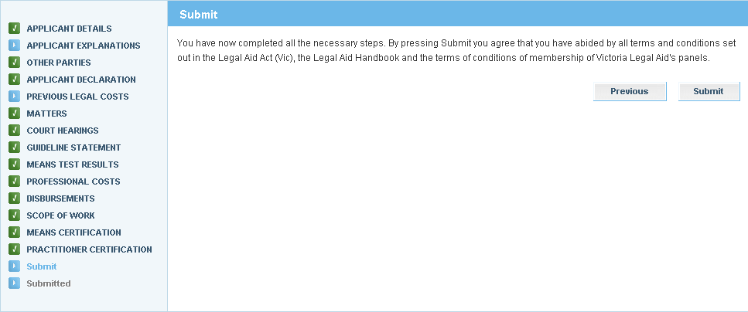

- A message will display to confirm the application has been submitted successfully.

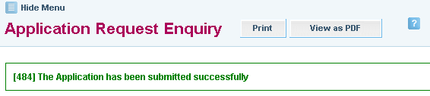

- A pdf copy of the application that has been submitted will be sent to your Inbox.

