An assigned practitioner may request that a grant of assistance be transferred OUT to another practitioner. This would most usually occur when a conflict of interest arises, or at the request of a client.

The assigned practitioner must:
- notify Victoria Legal Aid using the ‘Transfer’ function
- use the ‘Update Client Details’ function to provide the client’s details (if required)
- submit outstanding claims using the ‘Submit New Claim’ function

Do not complete ‘File Outcome’ as the file is being transferred and is ongoing.

To seek a transfer out to another practitioner

- Select Transfer from the left hand menu under Applications.

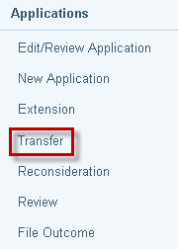

- The Search for File screen displays. Enter File ID and click on Search.

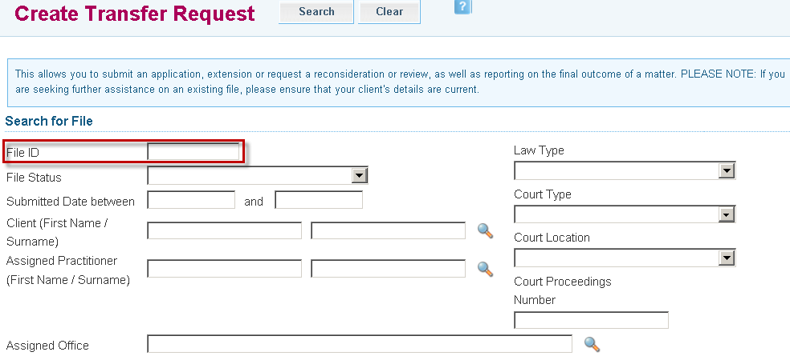

- Search results appear at the bottom of the screen. Click on the File ID link to retrieve the file.

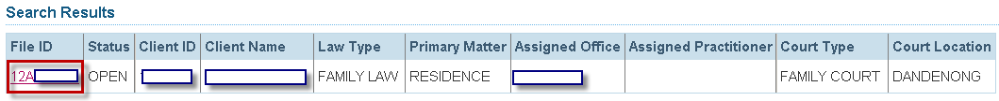

- The Transfer screen will display. Complete all required fields.

- Transfer reason: select the relevant reason
- Nominated Office or practitioner accepting the transfer: complete if known or leave blank for allocation by VLA
- Progress of case: provide details of the status of the file
- Outstanding claims: provide details of the outstanding claims against the file

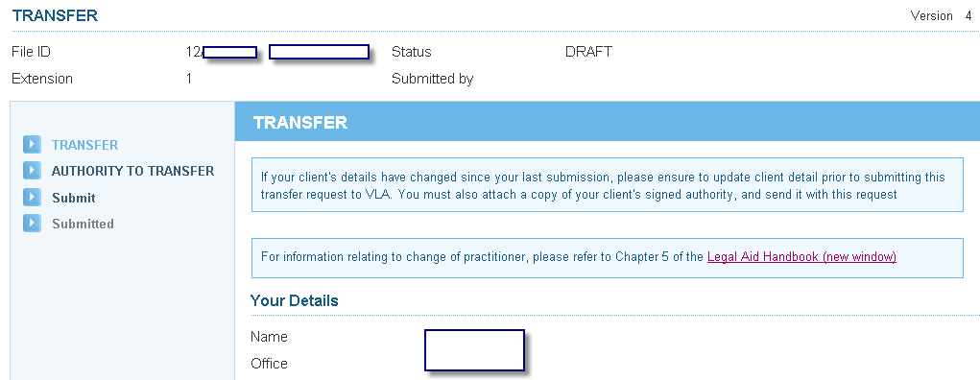

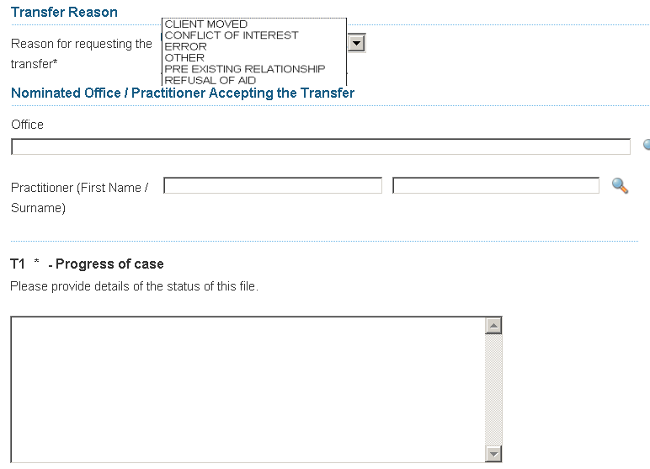

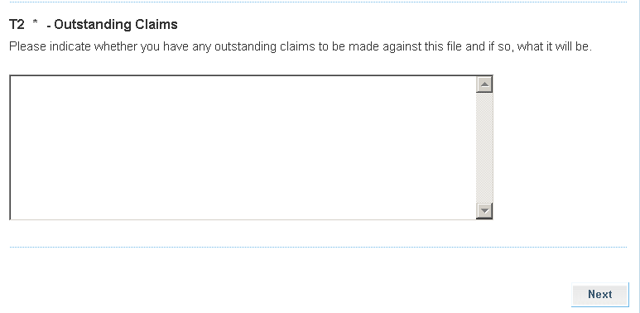

- The Authority to Transfer screen will display. Complete as required and select Next.

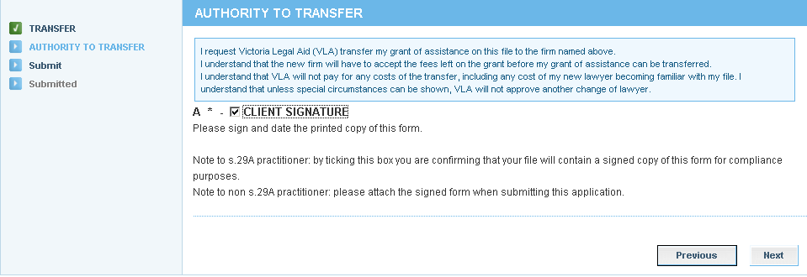

- The Submit screen will display. Select Submit:

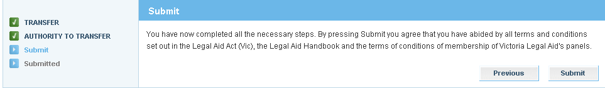

- The Attach Supporting Documents screen displays. If you do not have any attachments, click Continue to proceed. To attach a document, click on Show File Upload Area.

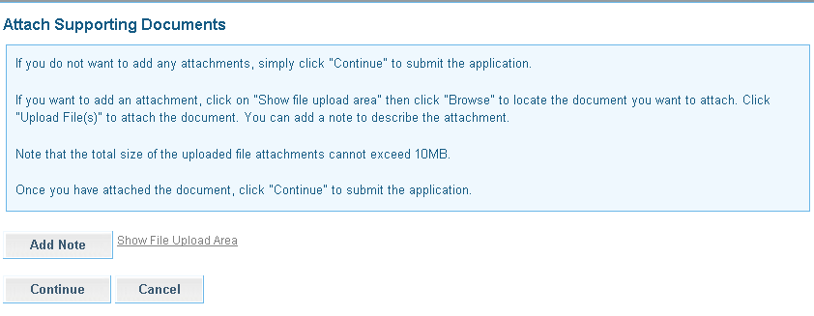

- The File Upload area will display. Click Browse and the Choose File dialogue box appears. Locate the file or document you wish to attach, click on Open to select it. The title of the selected document will populate in the field.
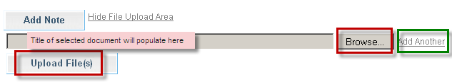

- Click Add Another if there are additional documents to be attached.

- Select Upload File.

- The File/Note Attachment grid will display with the relevant document(s).
To delete your attachment (if incorrectly attached) click the icon in the Action column.
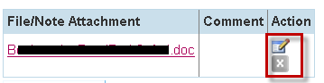

- To add or edit a Comment to describe the attachment, click the icon in the Action column.
Enter the comment, then click to save the comment. Click to delete the comment.

ATLAS has a 10 MB limit on the size of file attachments.

To avoid an error, split large attachments into two or more parts before attaching.

- To add a Note only, click Add Note.
Enter your Note and click to save the note or comment.
Click to delete the note or comment.
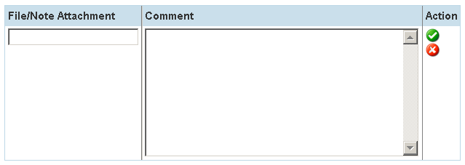

- Click Continue to submit the application. A message will display to confirm the application has been submitted successfully.

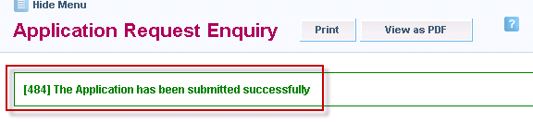

- Click either the Print or View as PDF button as required.



- A pdf copy of the extension application that has been submitted will be sent to your Inbox.

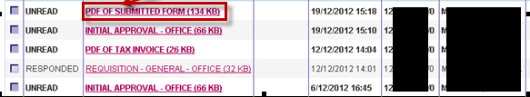

- VLA Assignments will process the request to transfer the grant of assistance. They will send transfer notification letters to the:
- original assigned practitioner
- new practitioner
- client (unless the client has chosen not to receive any correspondence)

- Use the ‘Update Client Details’ function to ensure that the client’s details are correct. Refer to the ‘Update Client Details’ user guide.

- Use the ‘Submit New Claim’ function to submit any outstanding claims to VLA. Refer to the ‘Submit New Claim’ user guide.

- You are not required to complete the ‘File Outcome’ screen as the file is being transferred and is still ongoing.

