How to pay Chambers’ advocates – a guide for private practitioners
All payments to Victoria Legal Aid Chambers advocates must be made through ATLAS and not by cash, cheque or bank transfer.

Step-by-step guide
- In the ATLAS home page, select Submit New Claim (located under the heading Claims).
- Enter the Gants reference (the ‘A’ number) into the File ID field.
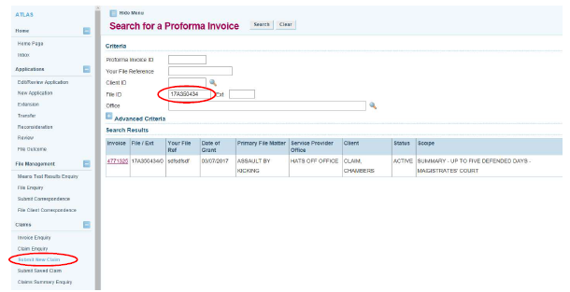
- Click on the relevant invoice that appears in the search results.
- A screen called Submit Payment Claim will appear. There should be a magnifying glass next to the Payee Service Provider field. If there is no magnifying glass, please contact the Grants & Quality Assurance team to have this rectified.
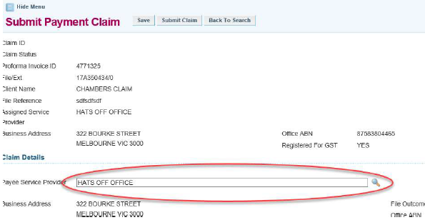
- Click on the magnifying glass next to Payee Service Provider. The Select an Office screen will appear.
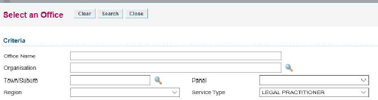
- Enter the name of the advocate you are paying into the Office Name field. (Format: first name, last name or %LASTNAME)
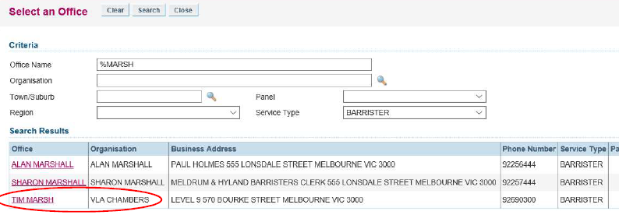
- The correct Payee is the advocate (as the office) and the organisation (as VLA Chambers).
- Select Barrister in the Service Type dropdown menu.
- Make the payment under the appropriate line item and select Submit.
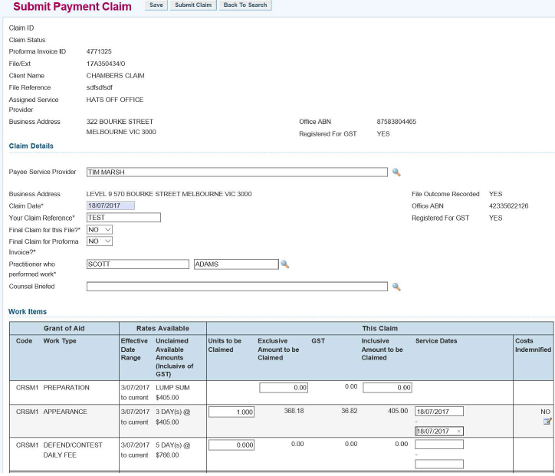
- A successful claim will generate a Claim ID number. Email this number to Advocates_Clerk@vla.vic.gov.au to confirm payment has been made.
