Appeal Costs Certificates (ACFs)
When a court has made an indemnity order (also known as an appeal costs certificate or an ACF) under section 17 of the Appeal Costs Act 1998 (Vic), you must follow this process.

1. Submit your Victoria Legal Aid (VLA) claim
Submit your claim, that relates to the ACF, through the ATLAS web. You must do this first, as proof of VLA payment is required when you claim reimbursement from the Appeal Costs Board (ACB).
Figure 1 - Click on 'Submit New Claim' on the left-hand side of the ATLAS web home page
When you submit the claim, make sure to mark it as ‘costs indemnified’ (Figure 2). This will tell VLA that a cost order has been made. It will also make sure that the claim item remains on your invoice so you can claim it later.
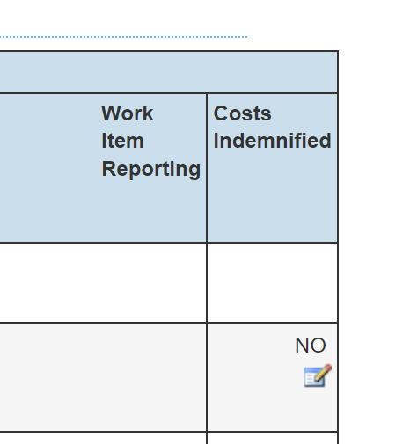
Figure 2 - Click on the costs indemnified icon to provide details of the order
After clicking on the costs indemnified icon, the screen below will open. Make sure to select ‘Appeals Cost Board’ as the agency.
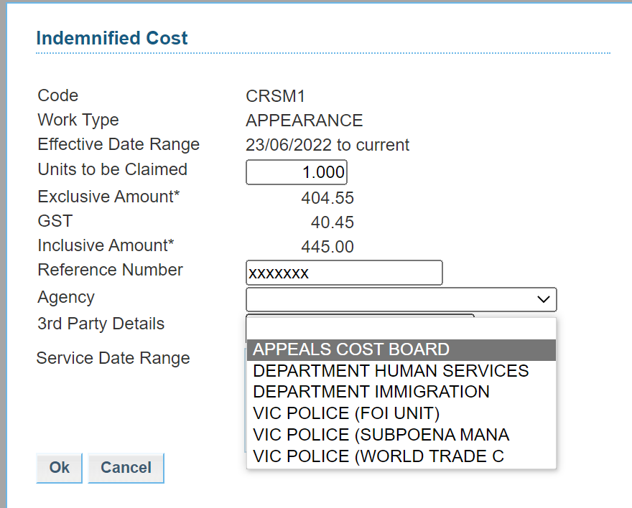
Figure 3 - Indemnified cost information screen

2. Lodge certificate with the ACB
You will need to lodge your ACF through the ACB Portal. If your office does not already have a login, simply click on the ‘register’ button.
Once you are logged into the ACB Portal, there is a simple step-by-step process to follow to lodge the ACF. Click on ‘Create new application’ or ‘Create application’. This will open a form requiring the following information:
- Section of the Act
- Applicant name
- Court type and reference number
- Date of certificate
- VLA reference number
- Details of the claim
You will then need to attach supporting documents such as your VLA remittance for the claim and Counsel’s fee slip (if applicable). Click submit.
Once the ACF has been submitted, you will receive an email acknowledgement. This is required for Step 3.
You can track the status of the application at any time by logging into the ACB Portal and checking ‘open applications’. You will receive a further email once your application has been processed.

3. Inform VLA’s Legal Recoveries Officer of ACB lodgement
You must tell VLA’s Legal Recoveries Officer that the ACF has been lodged with the ACB. You can do this by sending an email to ACF@vla.vic.gov.au or by using the ‘submit correspondence’ button on the ATLAS web homepage. Please make sure you provide a copy of the ACF and a copy of the ACB lodgement acknowledgement.

