This process guide has been prepared by our team of Practitioner Support Officers. If you have any access issues, or for any reason wish to contact Victoria Legal Aid about content on this page, please contact grantstraining@vla.vic.gov.au.

Extension request
An extension request should be submitted when you require further funding for an existing application.

Steps:
- Select Extension from the left-hand menu under Applications.
- Search for the file ID for the existing matter.
- Enter the file ID and select Search then click on the File ID.
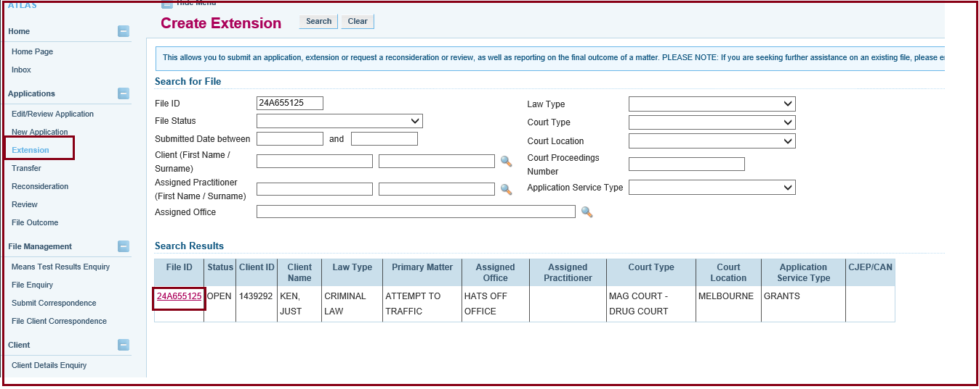
- Select the applicable template based on your existing matter.
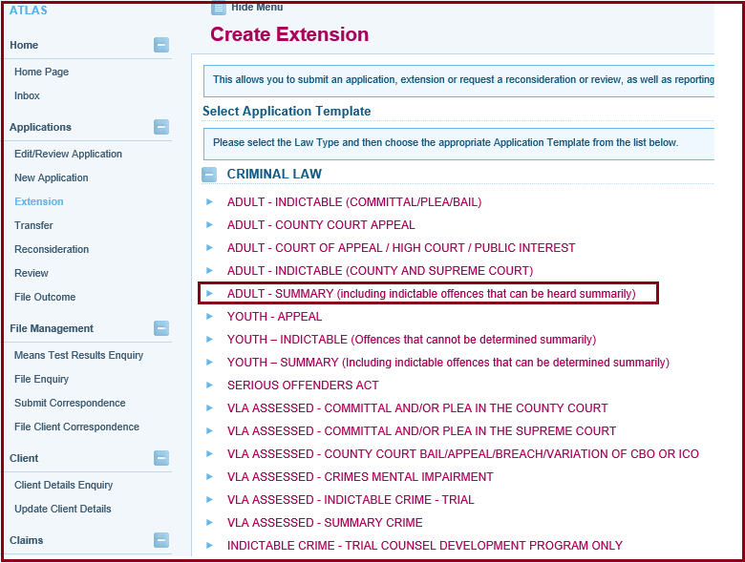
- The extension number stays 0 while in Draft status. It will change when the extension has been submitted.
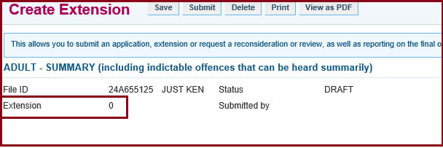
- The Applicant Details are displayed. Your client’s details will already be pre-populated based on the latest application you submitted to us. Check their details and update the information, if required.
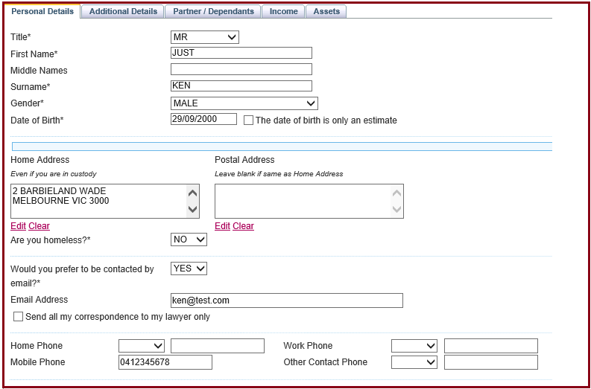
- The Matters screen will appear. It will contain Matters entered in the original application for aid. If the primary matter has changed, select the correct matter type or click Add if another brief needs to be added. Click Next.
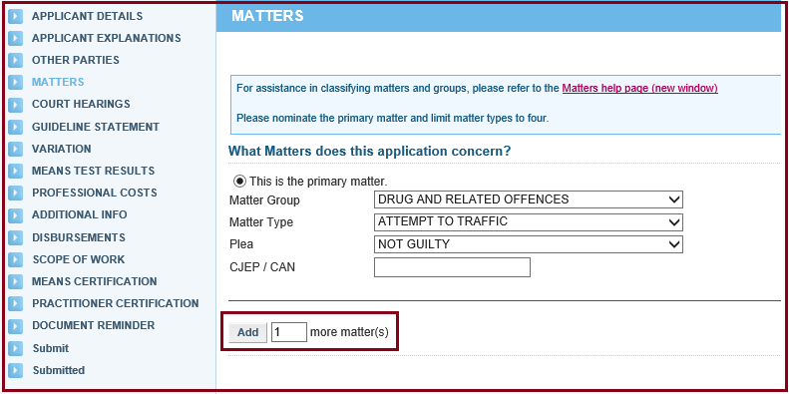
- Complete the Court Hearings screen. Click Next.
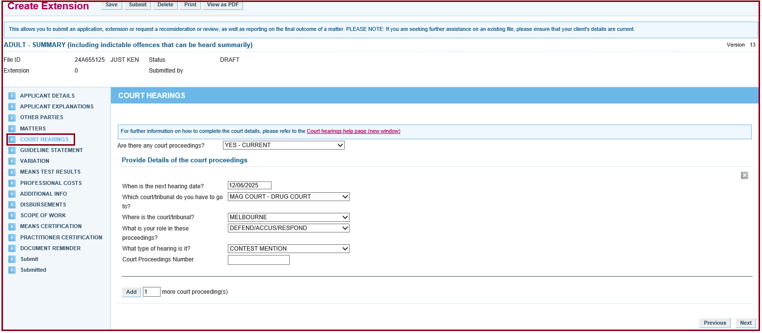
- The Guideline Statement screen will appear. Choose the appropriate Guideline that you are assessing the matter against and click Next.
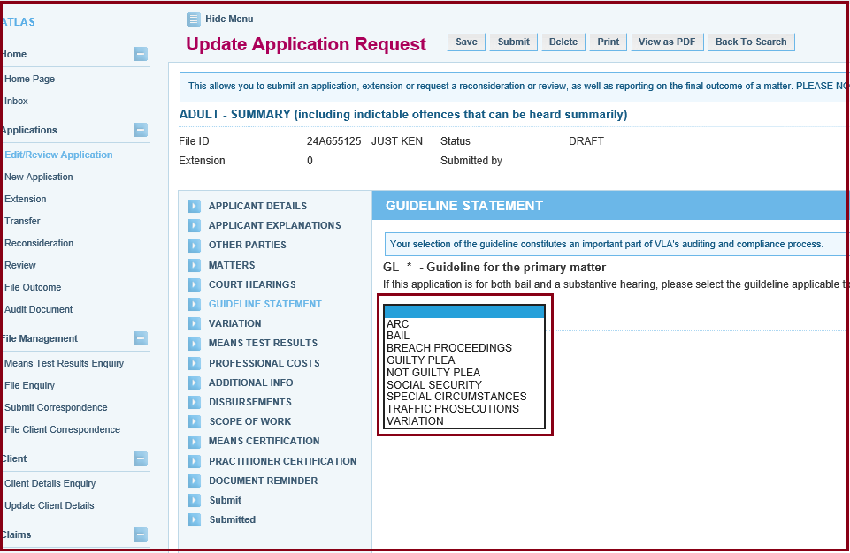
- The Means Test Results screen will appear: The results are based on the information entered for the client. If a contribution has been imposed or your client is ineligible on income or assets, your client can request discretion. If you choose Yes, then you need to provide reasons why discretion should be exercised in the text box. Click Next.
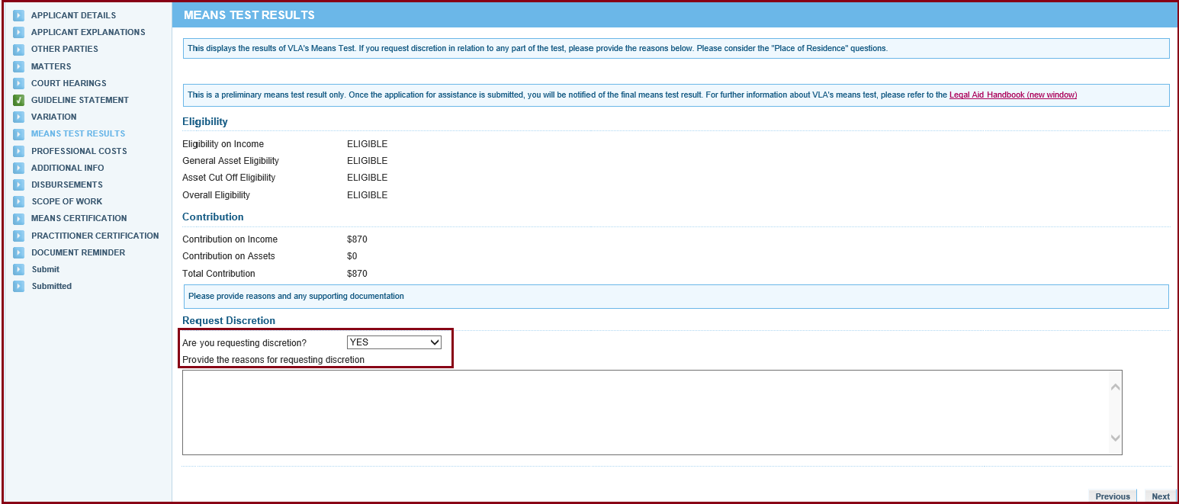
- The Professional Costs screen will appear. Here, you can select the extension of aid sought, including professional costs, if required.
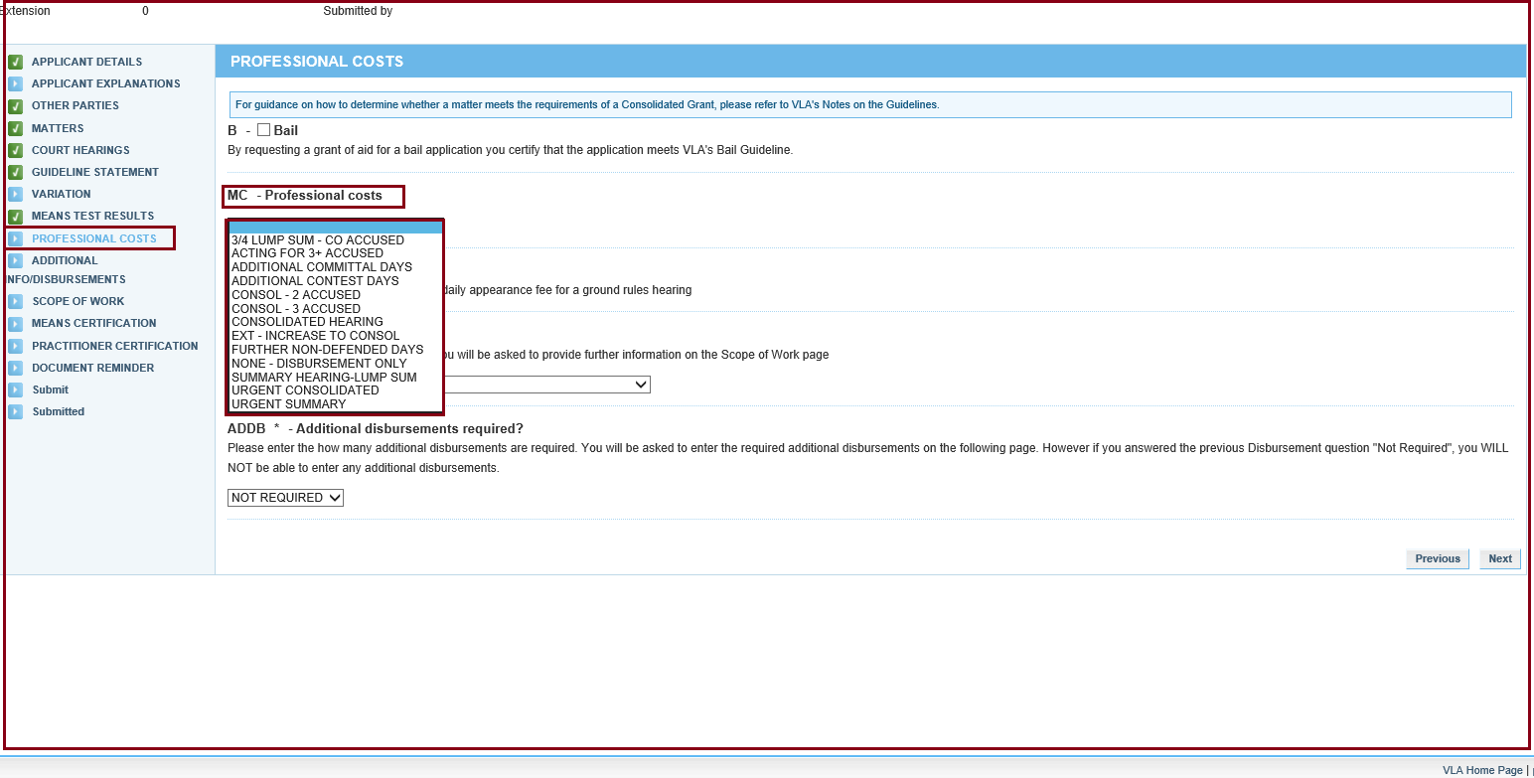
- You can also choose from the Disbursement drop-down list.
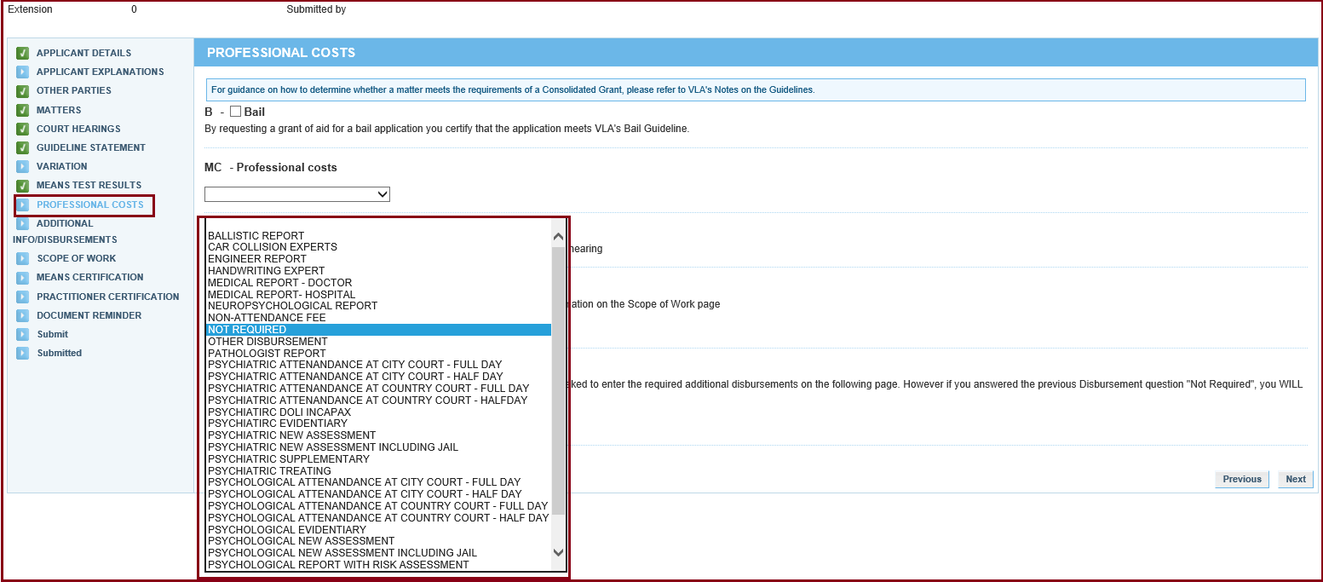
- Indicate if you want any additional disbursements. Then click Next.
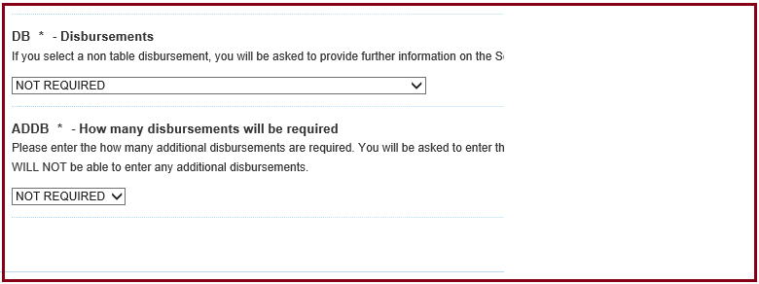
- If you are selecting a special disbursement, you may have to provide reasons for your request and any relevant supporting documents. For example, if you are requesting a special disbursement for a neuropsychological report and assessment, please provide a quote for the assessment and report and address the criteria described in the screenshot below. You can attach these documents before submitting your application or as correspondence on the file after submitting the extension.
- The Scope of Work screen will appear. This is a summary of the extension that has been requested. Sometimes an explanation is required for disbursements. You may also need to indicate the cost of the disbursement if it is not set in a fee table.
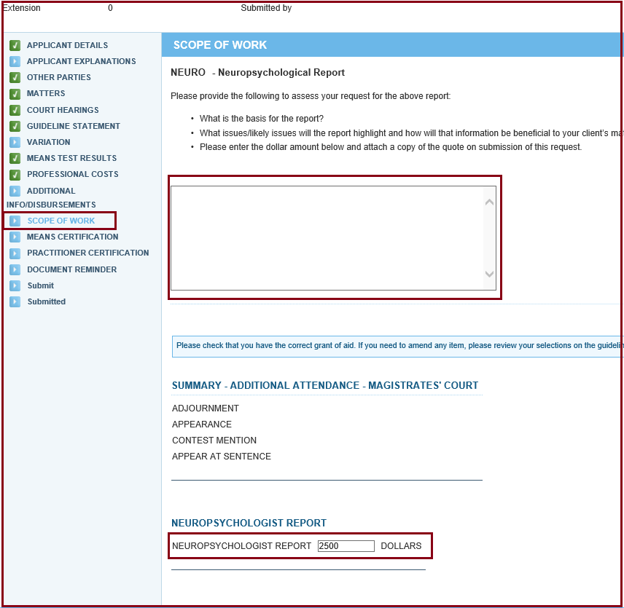
- For the Means Certification section, read each of the certification options and select the one applicable. Ensure that you have obtained all the relevant financial documentation for proof of means, if required. Click Next.
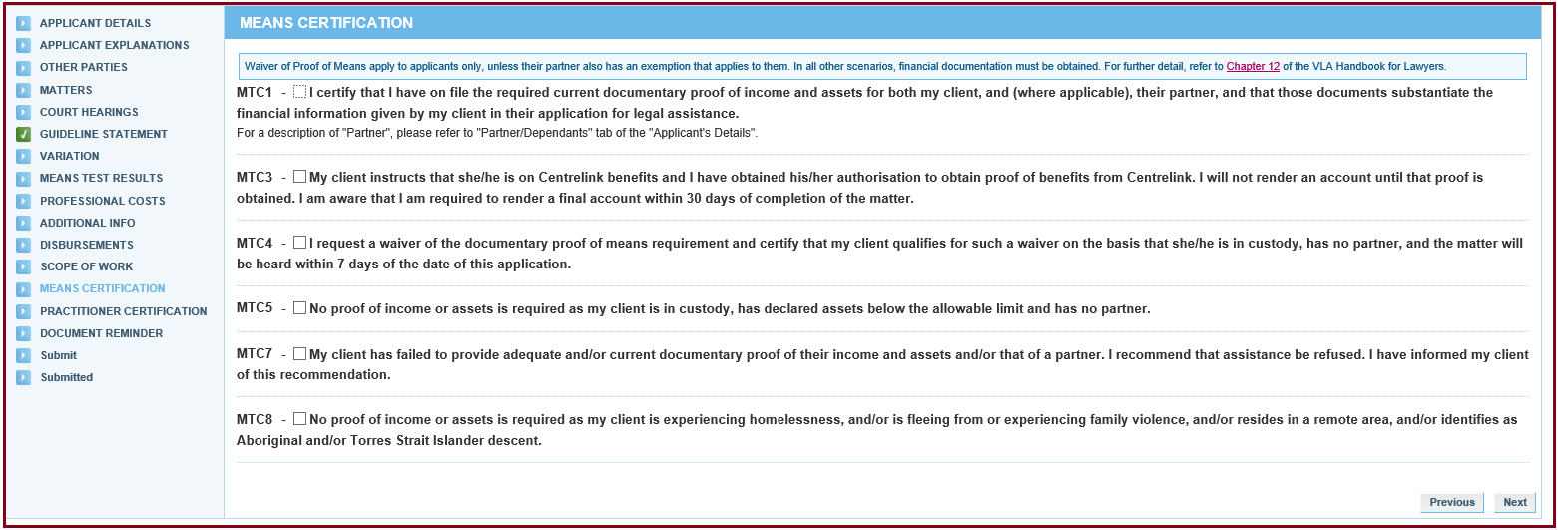
- The next screen is the Practitioner Certification page. Here the s29A certifier for the Panel, needs to certify that the matter either satisfies or does not satisfy the Guidelines and Merits. The Certifier can also ask for discretion for VLA assessment by selecting ‘not satisfied – discretion'.
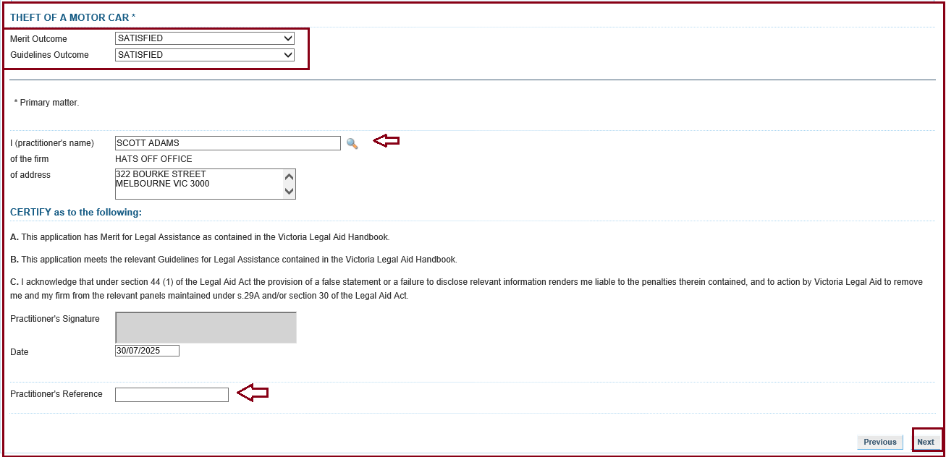
- After the Practitioner Certification pag\e, the Attach Supporting Documents screen appears. If you do not have any attachments, click Continue to proceed. To attach a document, click on Show File Upload Area.
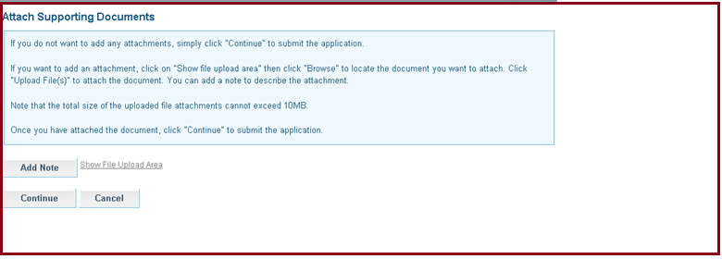
- Click Continue to submit the application. A message will display to confirm the application has been submitted successfully. The Extension number appears at the top of the screen.
