This process guide has been prepared by our team of Practitioner Support Officers. If you have any access issues, or for any reason wish to contact Victoria Legal Aid about content on this page, please contact grantstraining@vla.vic.gov.au.

File Outcome
File Outcomes must be submitted within 30 days of the matter finalising.

Steps:
- Click on the File Outcome option from the left-hand menu under Applications.
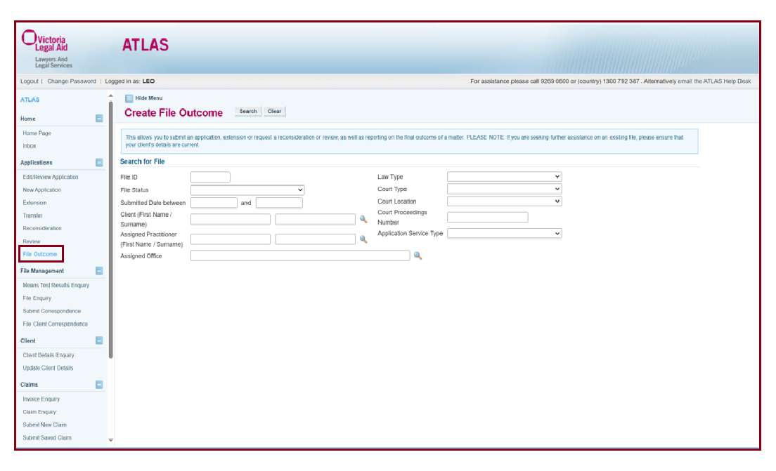
- Enter the File ID and click on Search and click on the File ID in the Search Results.
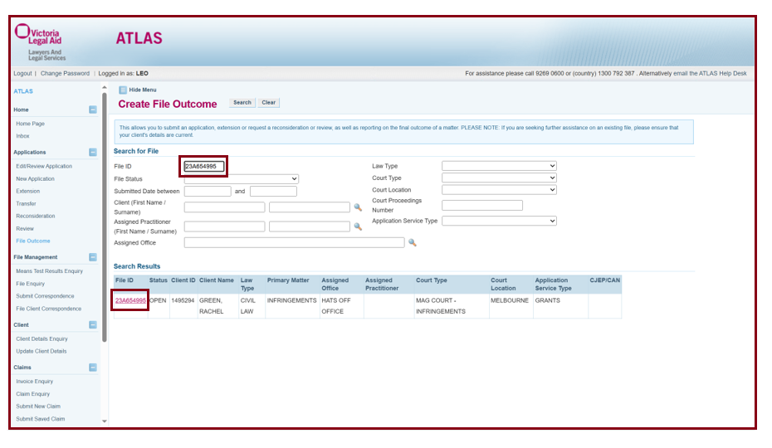
- Choose the relevant information in the drop in boxes.
- Select the correct option for each question. Not all the options will match the outcome of your client’s matter. Please select the closet option in this circumstance. Once you have made your selections, click on Next to submit.
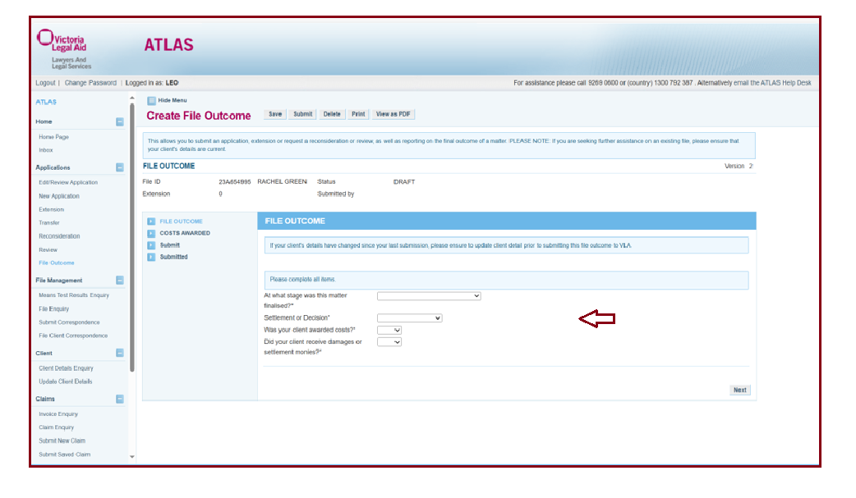
- Once submitted, this will close the file.
- The file will automatically close within two weeks and this will give you the opportunity to submit any outstanding claims on the matter.
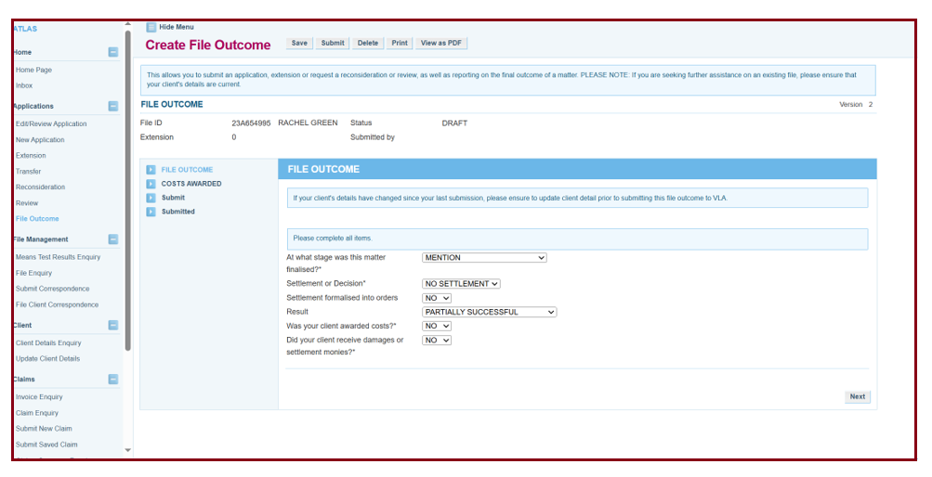

Additional Information:
- Only submit a file outcome when the legal matter has finalised.
- Ensure that all claims are finalised and submit a file outcome within 30 days of the finalisation of the legal matter.
- ATLAS will automatically close the file in 14 days.
- If file outcomes are not submitted, the files remain open and ATLAS will flag any future applications for your client as duplicates, meaning they may not be subject to automatic approval.
- Please do not select ‘VLA Closure’ from the drop-down list as this is for Grants use only.
- If you require a missed or further claim to be submitted, please email grants@vla.vic.gov.au and request that the file be reopened.

