This process guide has been prepared by our team of Practitioner Support Officers. If you have any access issues, or for any reason wish to contact Victoria Legal Aid about content on this page, please contact grantstraining@vla.vic.gov.au.

How to pay a barrister
Claims for the barrister must be paid directly to the barrister and not to the firm.

Steps:
- To pay a barrister directly click on the magnifying glass next to the Payee Service Provider column.
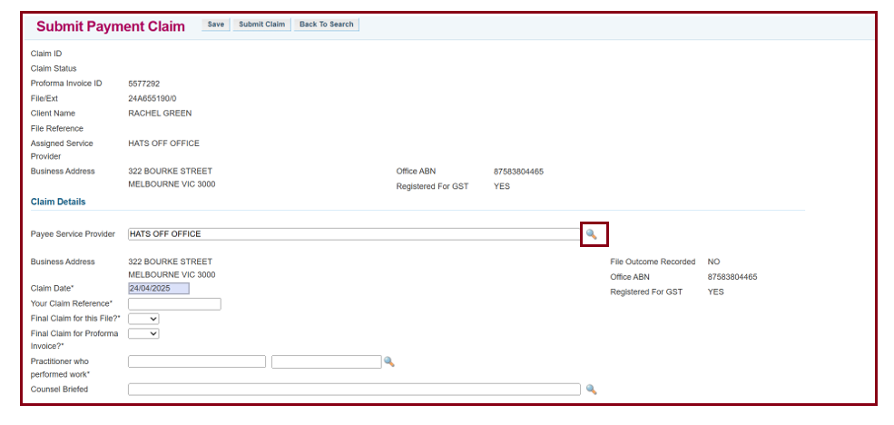
- Select BARRISTER as the Service Type. Type the barrister’s name into the Office Name.
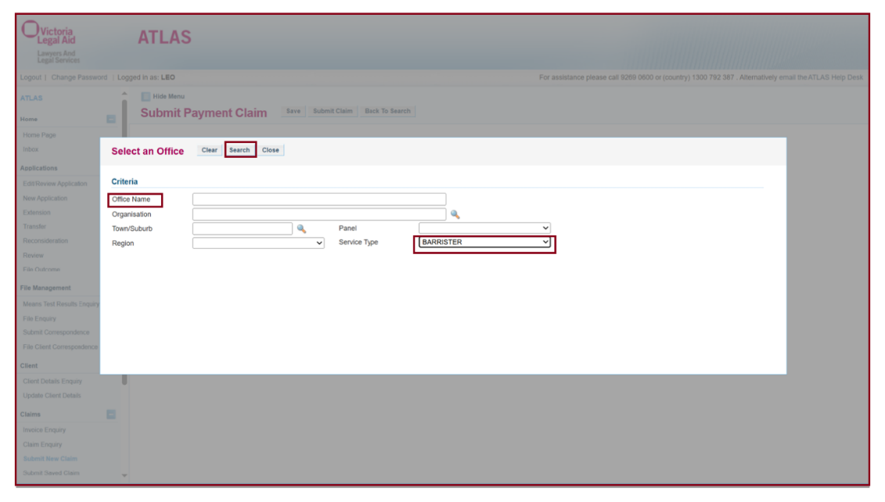

- You do not need to enter the barristers full name for the search function to work. Click on the barrister you need to pay from the Search Results
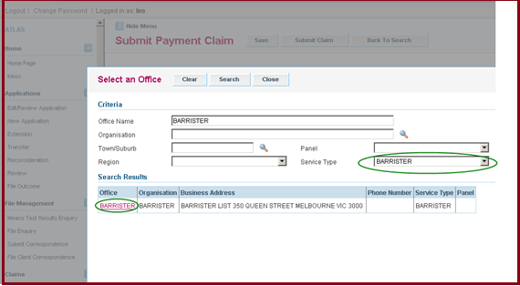
- Their details will auto populate into the claim screen.
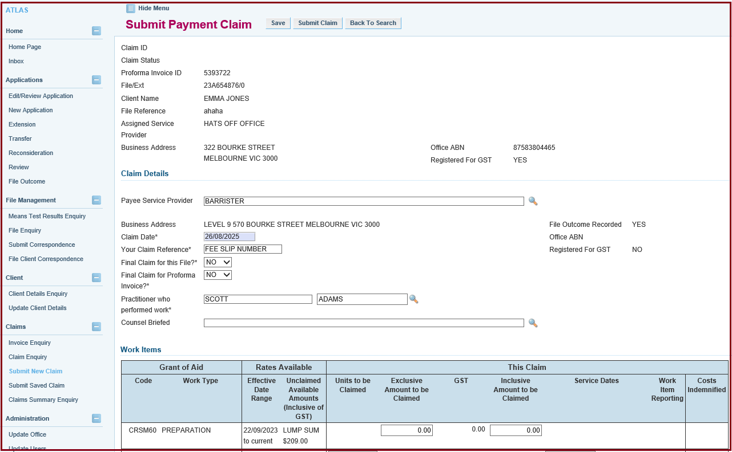
- In the section ‘Your Claim Reference’ enter the fee slip number found on the barrister’s invoice. It is mandatory to use the fee slip number so that the clerks can confirm receipt of payment.
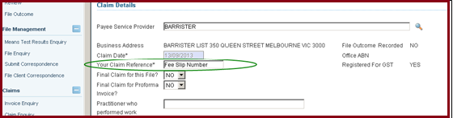
- Once the claim screen has been completed, click submit and a message in green will display confirming your claim has been successfully submitted.
- Once the claim has been certified, a pdf copy of the claim that has been submitted will be sent to your Inbox

Additional Information:
- If you can’t find the barrister in the search function:
- Ask the barrister to provide you with a current invoice which lists their bank account information, ABN number, and contact details.
- Email a copy of the invoice to Grants@vla.vic.gov.au and ask that the barrister be added into ATLAS for direct payment.
- If you paid the firm instead of the barrister:
  - Email Grants@vla.vic.gov.au and ask for a credit note to be issued against the claim.
- The credit note will cancel the claim, and the funds will reappear in the grant. The claim can then be resubmitted to be paid to the barrister.
  - Please provide a copy of the invoice with your request.

