This process guide has been prepared by our team of Practitioner Support Officers. If you have any access issues, or for any reason wish to contact Victoria Legal Aid about content on this page, please contact grantstraining@vla.vic.gov.au.

Requisitions
A requisition is a request for further information regarding an application for a grant of assistance. You need to respond to the requisition within the required time.

Steps:
- Requisitions will be received via the ATLAS Inbox.
- Click on the Inbox option from the left-hand menu under Homepage.
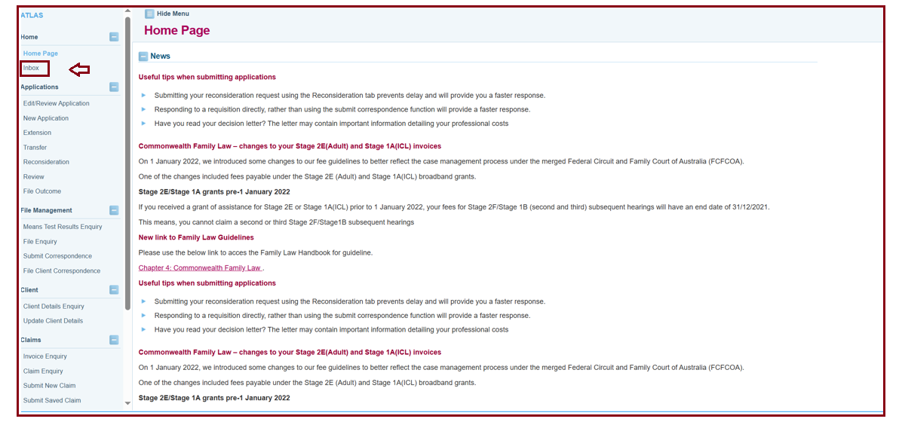
- Requisitions can be easily identified within the ATLAS Inbox. They will appear as follows:
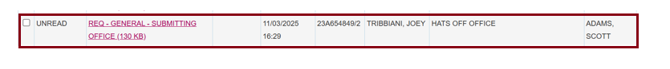
- Click on the File/Note Attachment to view the requisition. A PDF of the requisition will appear. This letter will detail what additional information we require from you.
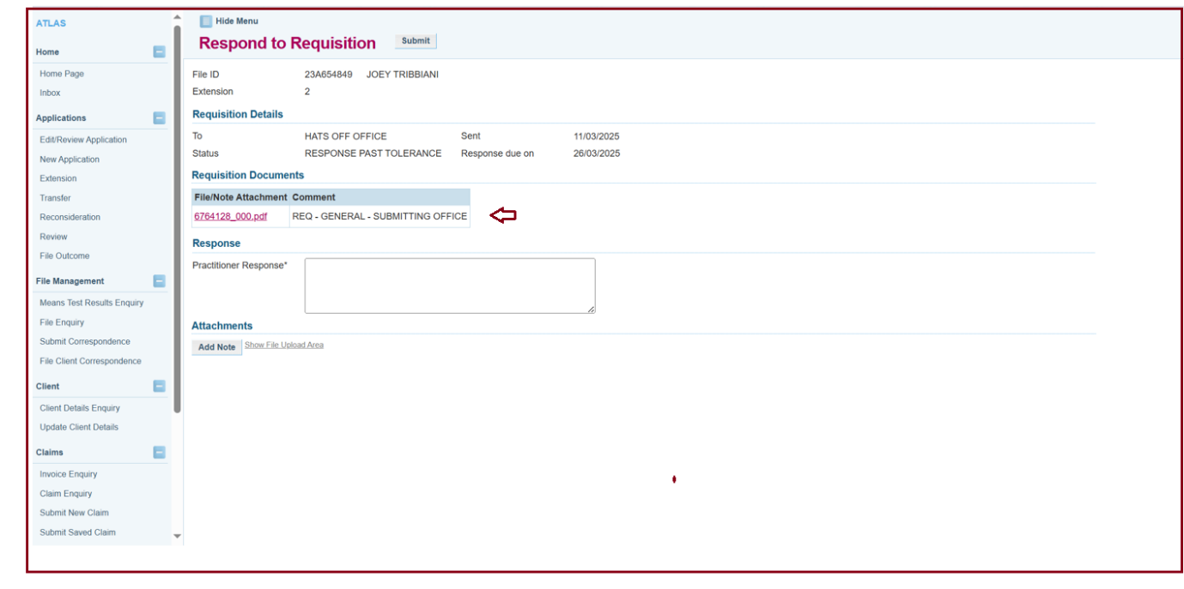
- The Respond to Requisition screen will open.
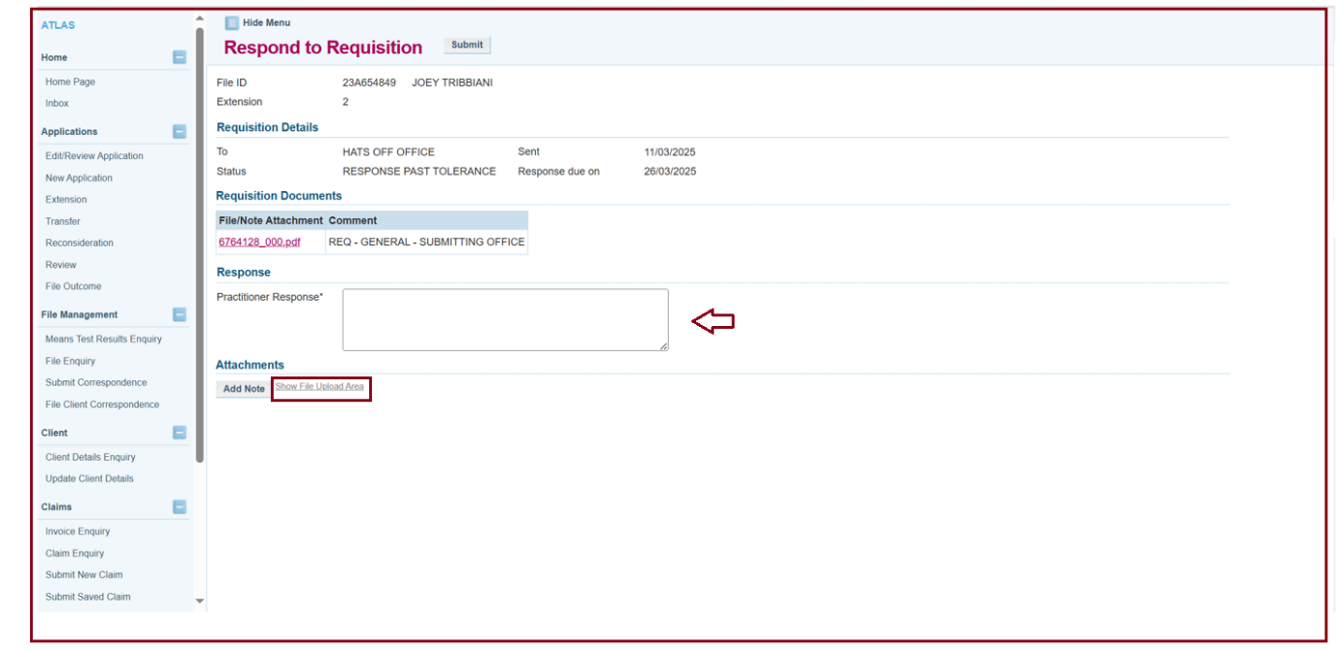
- To respond to the requisition, enter a response in the Practitioner Response box.
- Upload supporting documentation (e.g. letter to VLA, copy of Centrelink Card, copy of a quote) by clicking the Show File Upload Area link within the Attachments screen.
- Click Submit once completed.

Additional Information:
- Use this function to respond to a requisition rather than using the Submit Correspondence function.
- Once you respond to the requisition via the ATLAS inbox, the grants officer who sent the requisition will be notified and the assessment can progress.

