This process guide has been prepared by our team of Practitioner Support Officers. If you have any access issues, or for any reason wish to contact Victoria Legal Aid about content on this page, please contact grantstraining@vla.vic.gov.au.

Review requests
Review requests should be submitted when you disagree with the decision that VLA has made at the reconsideration stage. Independent reviewers are not VLA officers. Their appointment is made by the Attorney-General of Victoria.

Steps:
- Click on the Review option from the left-hand menu under Applications. Search for the File ID for the matter for which you are requesting the decision to be independently reviewed.
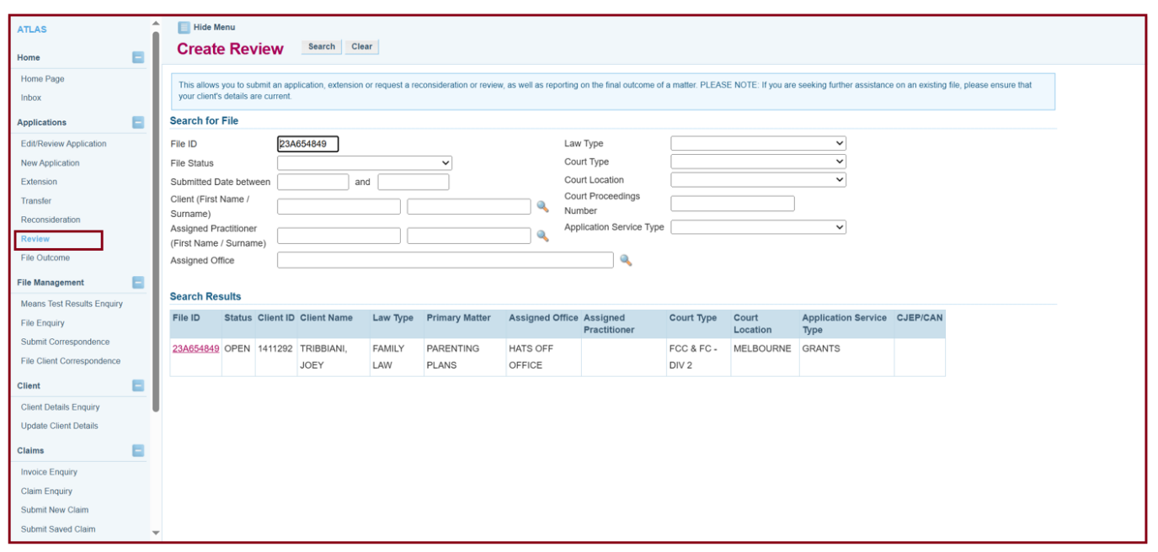
- Then click the File ID in Search Results.
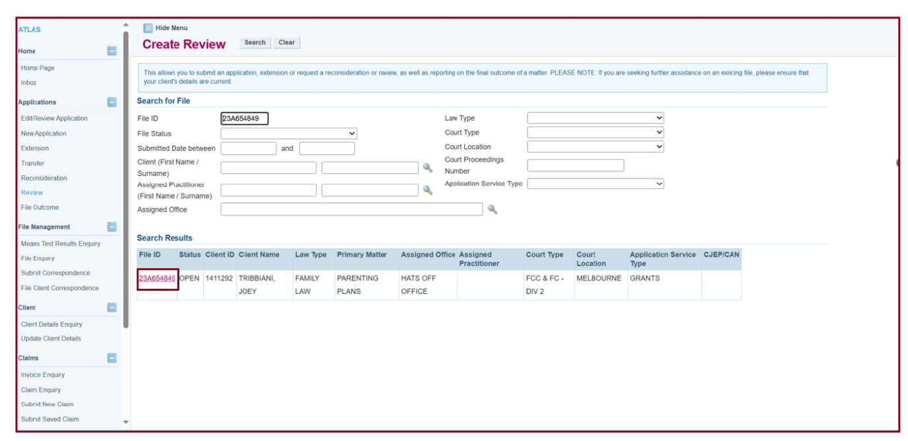
- In the extension box, enter the relevant extension you are seeking the review on. If it is the initial decision, then the extension will be 0
- Select the grounds for which you are seeking the decision to be reviewed. If the option is not here, then select Other and provide your reasons
- Ensure that you provide adequate information in the text box. If you do not have sufficient space to detail your reasons or wish to provide supporting documentation, you will need to attach them through the Submit Correspondence tab after you have submitted the review request. Click next.
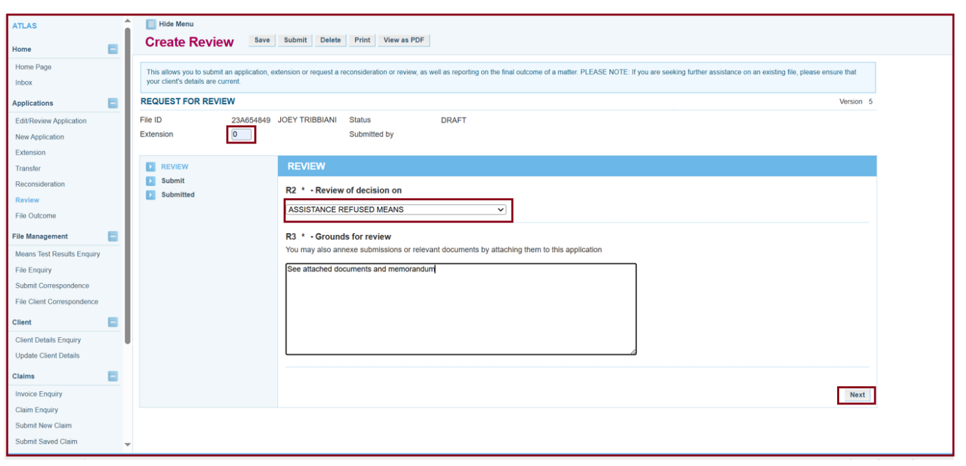
- Click on the submit button.
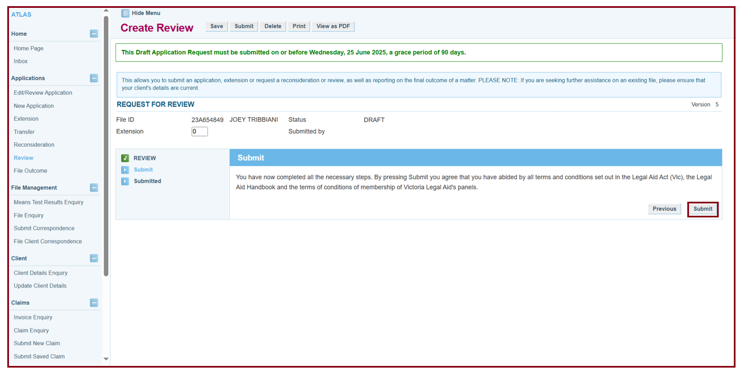

Additional Information:
- Requests to review a decision must be received within 21 calendar days of the reconsideration decision.
- In most matters, VLA may waive or extend the time in which a person can request independent review of a decision. However, VLA will not waive or extend the time limit if the request for independent review relates to either a criminal trial or a criminal appeal in the County Court or in the Supreme Court.
- Review requests must be submitted via the Review function on ATLAS. It is not sufficient to submit the request through the correspondence tab or via email.
- The decision of the independent review is final.

