This process guide has been prepared by our team of Practitioner Support Officers. If you have any access issues, or for any reason wish to contact Victoria Legal Aid about content on this page, please contact grantstraining@vla.vic.gov.au.

Submitting a claim including indemnified claims

Steps:
- Click on the Submit New Claim from the left-hand menu under Claims.
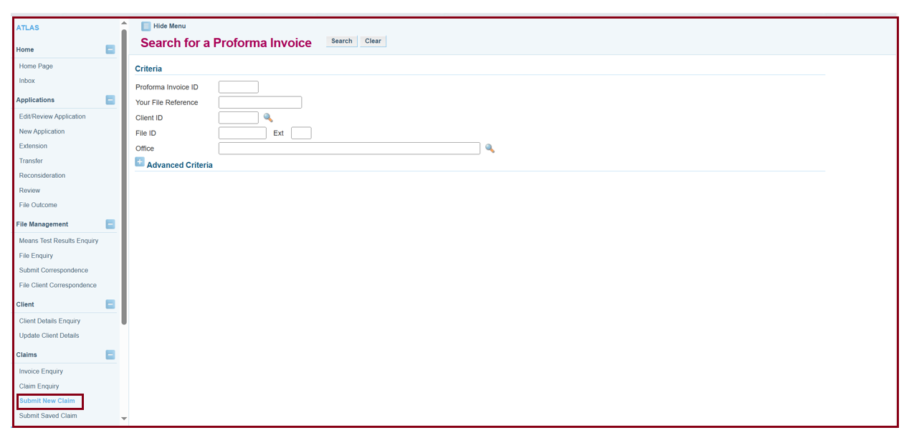
- Enter the File ID and click on Search to find the pro forma invoice.
- Click the Invoice link and the Submit Payment Claim screen will appear.
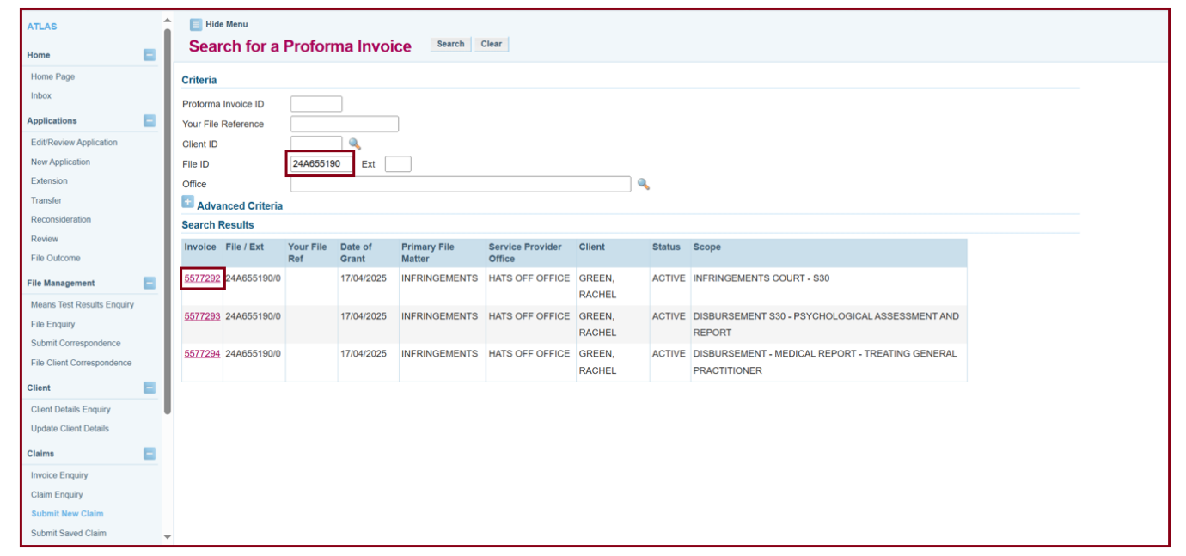
- The Submit Payment Claim screen will appear. Fill in the Claim Date, Your Claim Reference which must be unique for each claim.
- If this is the final claim for the File, choose ‘yes’ and a File Outcome screen will appear.
- If this is the final claim for the Proforma Invoice, then select ‘yes’
- The Practitioner who performed the work needs to be searched for using the magnifying glass.
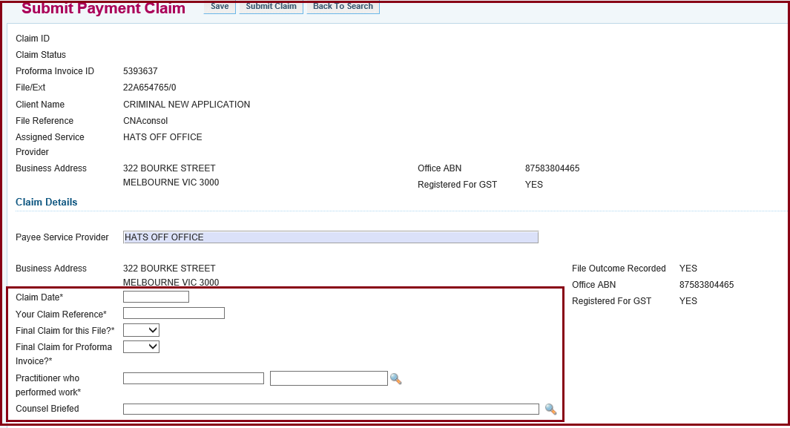
- In the Work Items section, complete Units to be Claimed or Inclusive Amount to be Claimed.
- One appearance fee is equal to one unit so under Units to be Claimed, enter in the number of appearances you wish to claim. You must put in the hearing dates under Service Dates. If there are multiple appearance days, enter in the first and last appearance dates.
- Fees such as preparation and disbursements need to be claimed as a lump sum so enter the amount you need to claim in the Inclusive Amount to be Claimed. ATLAS automatically calculates the GST component of the claim.
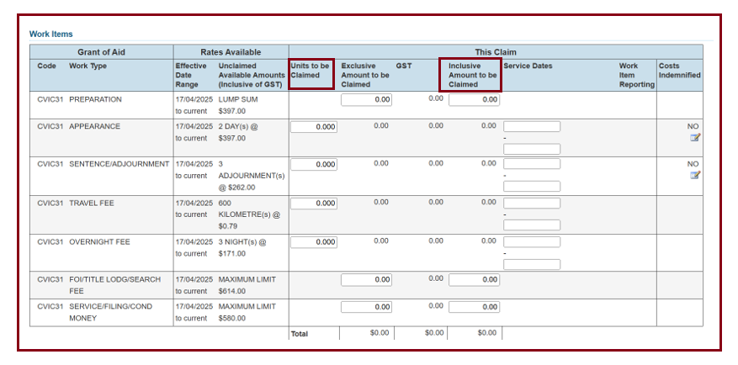
- The certifier will need to look over the claims selected, once their name is entered at the bottom, go up the top and select submit claim.
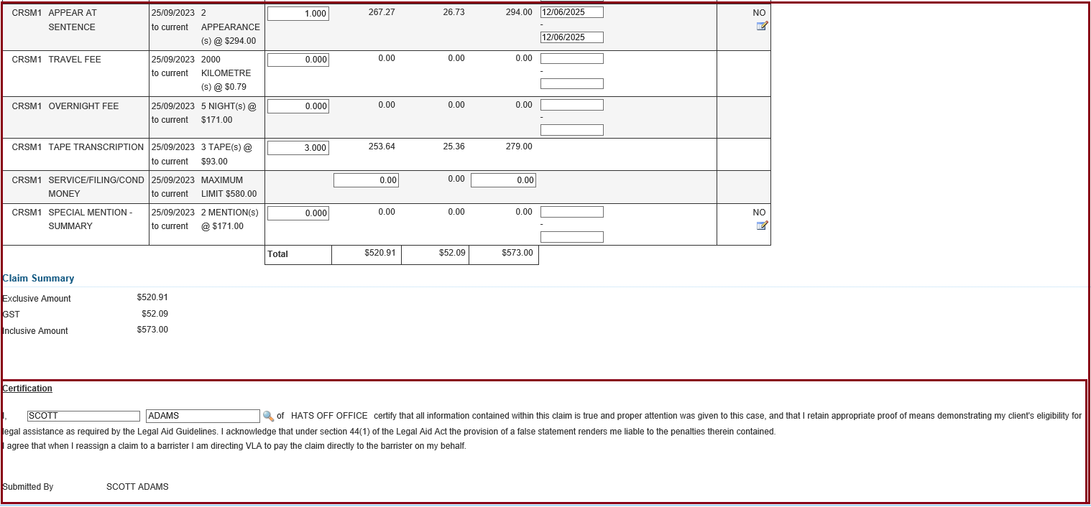

If costs were awarded
- If you need to claim an appearance where Costs were awarded, enter the details of the claim including the service dates and then click ‘No’ under the ‘Costs Indemnified’ column.

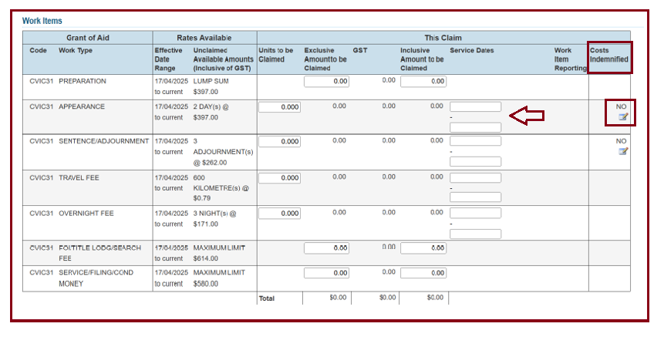
- A box will appear with required information, select the units to be claimed, reference number as per costs order and choose Agency from the drop-down box or Third Party. Then a green tick will appear. Click the green tick, then OK.
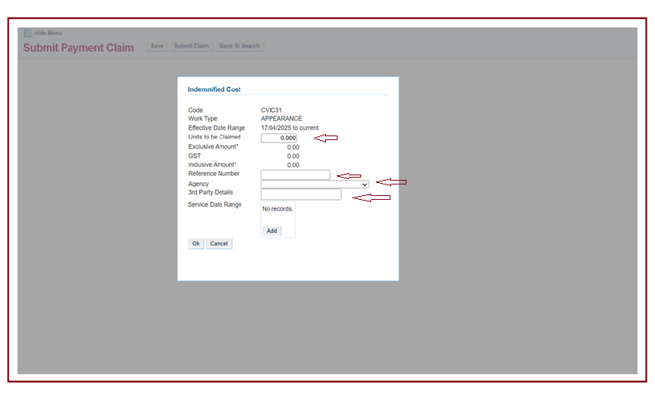

- Attach the costs indemnified certificate under the Submit Correspondence ATLAS menu item.

Additional Information:
- If you click 'save claim' this won't be submitted.
- Multiple claims can be made against an invoice for work items with multiple units such as additional hearing days.
- If you make an error on a submitted claim, use the ‘Submit Correspondence’ function in ATLAS or email to notify VLA of details of the adjustment required.
- If an incorrect claim has been made, please contact grants@vla.vic.gov.au and a credit note can be issued to rectify the error.
- Claims can be saved and submitted later, just click on save at the top of the screen and the claim can be accessed again later.
- If the File has been closed or Proforma Invoice is inactive, and you have further claims, please contact grants@vla.vic.gov.au.

