This process guide has been prepared by our team of Practitioner Support Officers. If you have any access issues, or for any reason wish to contact Victoria Legal Aid about content on this page, please contact grantstraining@vla.vic.gov.au.

Submitting a Transfer Request
Transfers for existing clients or prospective clients can be submitted via the transfer tab or through Submit a New Application.

Steps:
- If you wish to transfer an existing client’s grant of aid, select Transfer on the left-hand side.
- Enter the File ID and click on File ID in the Search Results.
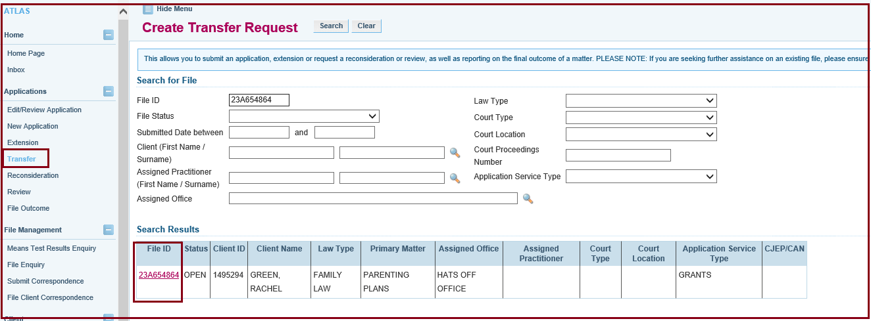
- The transfer screen will appear and select the reason for the transfer.
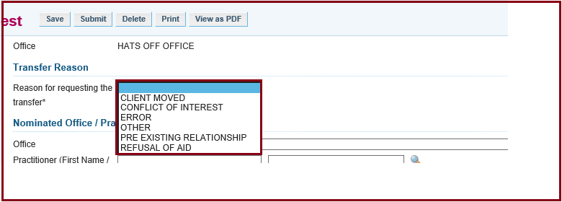
- Select the nominated office or practitioner accepting the transfer. To do this, click on the magnifying glass for either the office or the practitioner.

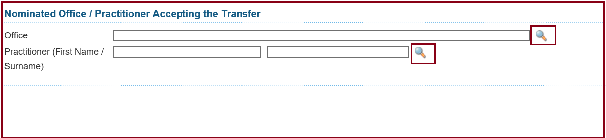
- Type in the office name or practitioner name and click search.
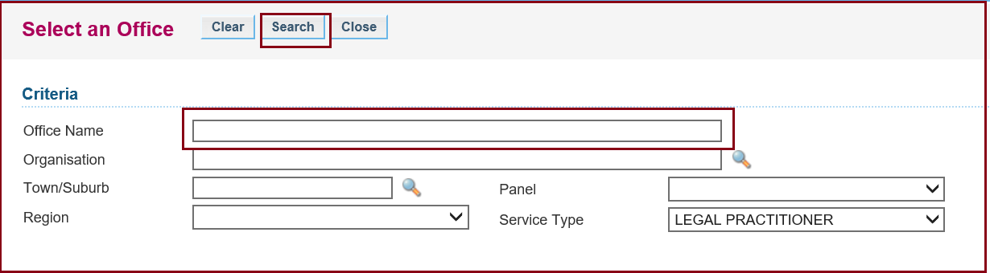
- Fill in the Progress of the case and if there are any Outstanding Claims. Then click Next.
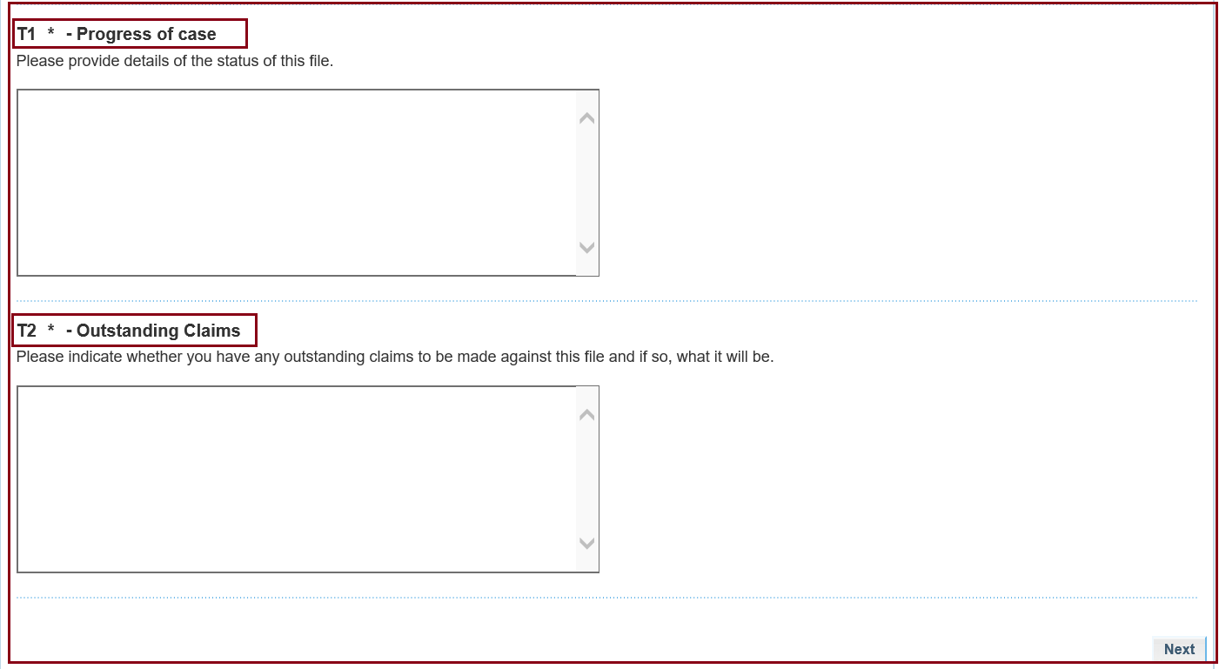
- Ensure that you have the client’s signature giving Authority to Transfer.
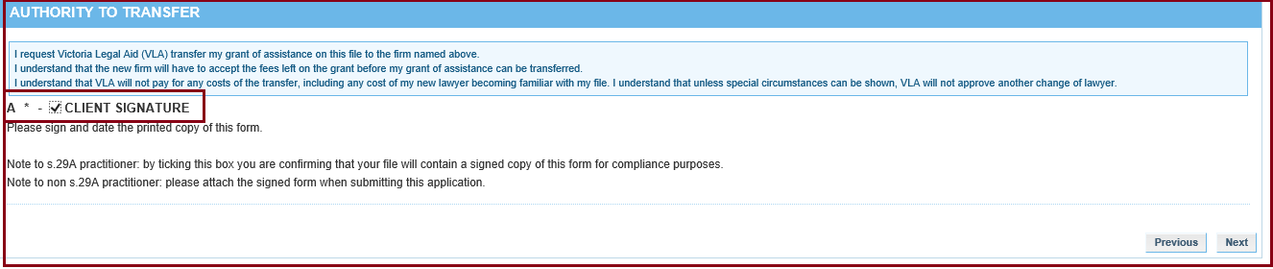
- Click Submit and you will be taken to the Attach Support Document screen. If you need to attach any documents, click on the Show File Upload Area and choose the documents you wish to attach. Click Continue.
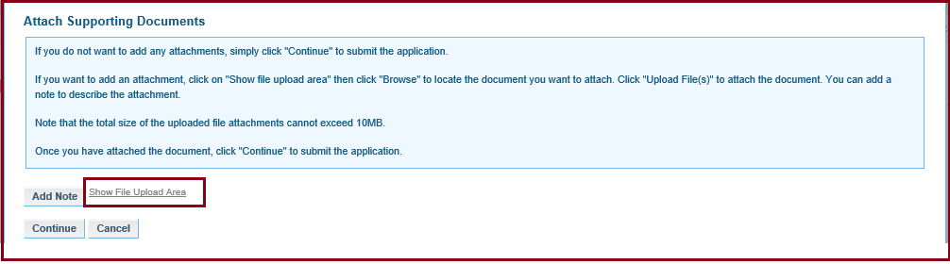
- You should now get notification that the transfer request has been successfully submitted.
- If a prospective client is requesting a transfer to your office, click New Application and then according to the law type, click Transfer from Another Office template.

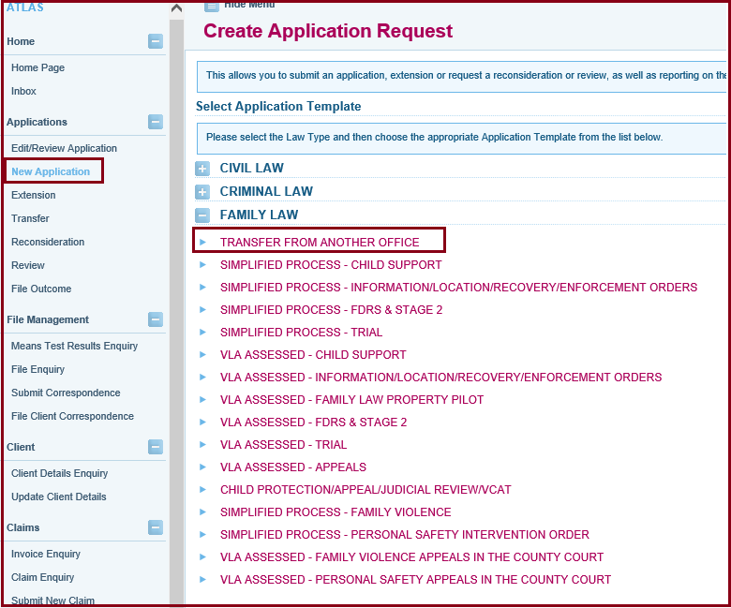
- Type in the client’s name and press search. Make sure the birth date and address are correct. Click on the client’s name in the Search Results.
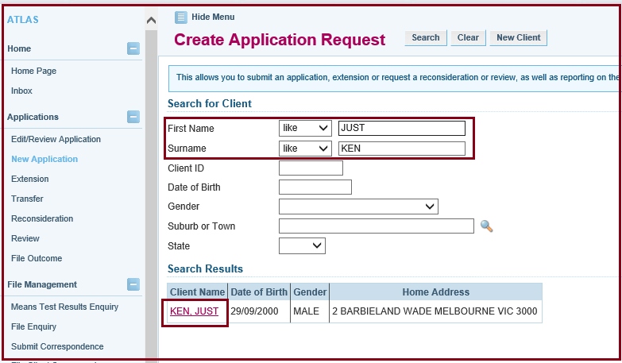
- The Applicant’s Details screen will appear. Fill in the text box at the top if this appears on the screen. Check with the client that their details are correct. Click Next.
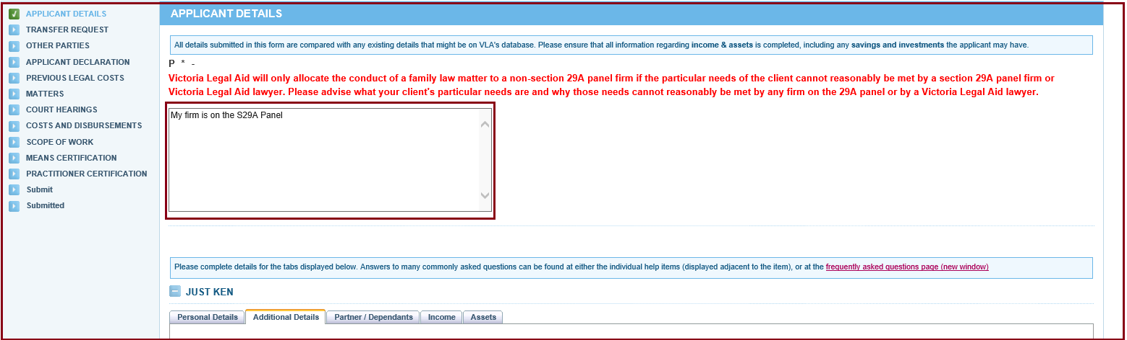
- Fill in the Transfer Request screen. If the client does not know the File ID, it can be left blank. Provide transfer reasons, the guideline that this matter pertains to and indicate that you have the authority to transfer from the client.

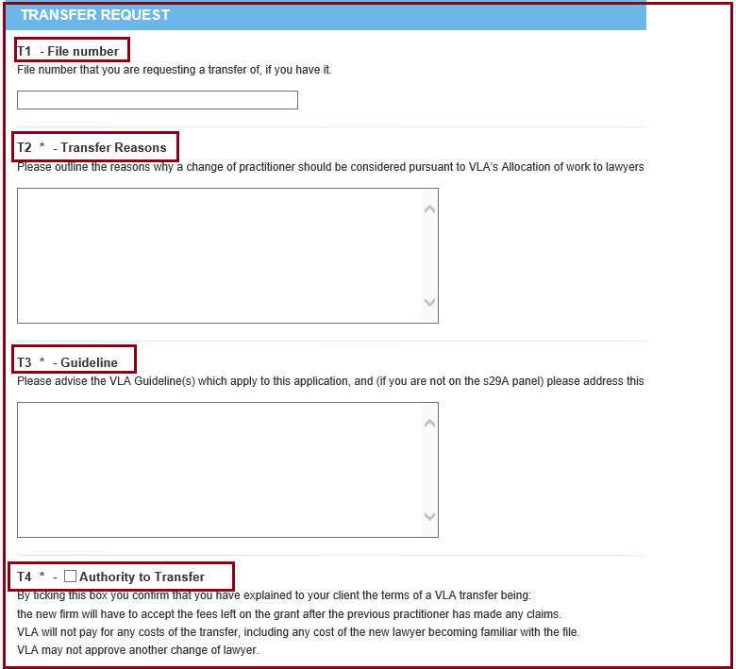
- Proceed through the Tabs on the left-hand side just like any other application or extension request.

Additional Information:
- When requesting a transfer of an existing grant, a new legal aid application form will need to be completed, as well as ensuring the client’s legal matter satisfies VLA’s guidelines, means and merits tests; and proof of means/matter are kept on file.
- Once submitted, your transfer request will need to be assessed by a Grant’s Officer. We often need to contact the previous law firm for merits advice or information about claims.

